The LRN-C Outreach Workbook: Responder Community
  - How to Create and Maintain Outreach Efforts to the Responder Community in a Laboratory Response Network for Chemical Threats (LRN-C) Program
September 2026
Contents
Introduction 3
About the LRN-C 3
How to Use this Workbook 3
Additional Outreach Resources 4
Acknowledgements 4
Funding Disclosure 4
Introductory Outreach 5
Part 1: Outreach Program Self-assessment 5
Part 2: Response Partner Identification 6
Part 3: Outreach Planning 7
Part 4: Barrier Mitigation 7
Part 5: Set an Outreach Plan 8
LRN-C Outreach Instructor Development 9
Part 1: Instructor Self-assessment 9
Part 2: Audience Analysis 10
Part 3: 60-second Elevator Pitch 10
Part 4: Action Plan 10
Two-year LRN-C Outreach Program Plan 11
Year 1 Plan 12
Year 2 Plan 13
Expected Outcomes by End of Year 2 14
Appendix: Tables 15
Table 1. LRN-C Action Options for Stakeholder Engagement and Program Effectiveness 15
Table 2. LRN-C Outreach Barrier Mitigation Reference 17
Table 3. LRN-C Options to Support and Develop Instructor Confidence 19
Table 4. LRN-C Common Challenges for Outreach Coordinators 20
Table 5. LRN-C Strategies to Improve Public Speaking 21
Table 6. LRN-C Body Language Strategies 22

Introduction

About the LRN-C
The Laboratory Response Network for Chemical Threats (LRN-C) is a coordinated national network founded by the US Centers for Disease Control and Prevention (CDC), the Association of Public Health Laboratories (APHL) and the US Federal Bureau of Investigation (FBI) to respond to chemical threats and public health emergencies. It is comprised of 54 state and local public health laboratories and the CDC National Center for Environmental Health’s Division of Laboratory Sciences. During large-scale national events, state and local LRN-C laboratories assist CDC in acquiring and testing samples for chemical exposures and serve as front-line conduits for communication among CDC and local health officials, hospitals and poison control centers. They also provide crucial local and state infrastructure that supports other important state and local public health programs.
The LRN-C links 54 state and local public health laboratories across the US and its territories. These laboratories operate at three levels that reflect their ability to perform various functions during emergency events:
- Level 3 laboratories work with hospitals and first responders to collect, package and ship human specimens to other laboratories for confirmatory testing
- Level 2 laboratories test specimens referred from Level 3 laboratories for toxic chemicals and metals, in addition to their level 3 capabilities
- Level 1 laboratories test for metabolites of chemical warfare agents, provide surge capacity testing for clinical specimens to CDC and network laboratories during large-scale emergencies, in addition to their level 2 and 3 capabilities.
All LRN-C laboratories conduct outreach to clinical, public health, first responder and law enforcement partners. Successful outreach programs foster these relationships through ongoing and active efforts. This proactive approach to relationship management leads to a more effective response during a chemical threat incident. This workbook provides actionable guidance for successful outreach efforts to the first responder community.

How to Use this Workbook
The APHL LRN-C Outreach Workbook: Responder Community was designed in partnership with the Wisconsin State Laboratory of Hygiene for new and current LRN-C staff, with the responder community in mind. This workbook provides self-assessment, planning templates and actionable items to build an LRN-C Outreach Program and develop relationships with the responder community.
Use this workbook to complete activities, capture ideas and develop your outreach plan and instructor skills. After completing the workbook, you will be able to:
- Evaluate your current outreach and relationship levels
- Establish outreach and relationship goals
- Identify barriers and apply solutions to outreach efforts
- Create a two-year plan for an outreach program
- Identify outreach language and actionable steps.

Additional Outreach Resources
- Partners in Preparedness and Response: Connecting Laboratories and the First Responder Community
- Field Device Use by First Responders: Issues and Solutions
- Framework Checklist for Public Health Laboratory Outreach to First Responder Communities​
- ​Algorithm and Guidelines for Responding to an Incident Involving a Suspicious Non-Clinical Sample​
- Decontamination of Select Agents Isolated in the Clinical Laboratory
- Chemical Threat Outreach Training: Stories of Success E-learning Course
- APHL Chemical Threat Agents Poster
- CDC Collecting and Labeling Specimens from People with Possible Exposure to Chemical Agents

Acknowledgements
APHL extends gratitude to Meshel Lange, MS, and Mason Shields at the Wisconsin State Laboratory of Hygiene. Ms.Lange created and led the in-person half-day LRN-C Outreach Training Workshop on March 3, 2026, and developed a workbook to accompany the training. With her permission, APHL has expanded the scope of her materials into this workbook for use by all LRN-C laboratories to improve outreach efforts. APHL also recognizes the CDC LRN-C program staff Amy Watson Hardnett, PhD, and Ryan Favors, MS, for support of the APHL Environmental Health Committee and Chemical Threat Collaborative Work Group, allowing for focus on the need for and the development of LRN-C outreach training materials.

Funding Disclosure
This publication is supported by Cooperative Agreement #20NU47CD000001, funded by the US Centers for Disease Control and Prevention (CDC). Its contents are solely the responsibility of the authors and do not necessarily represent the official views of CDC or the US Department of Health and Human Services, APHL or its member laboratories.

Introductory Outreach

Part 1: Outreach Program Self-assessment
To begin, rate your current outreach program effectiveness. Use the description table below. Program effectiveness will change and evolve over time but establishing current and goal levels will guide program activities. After completing the workbook, return to the Post Workbook Follow-up Self-assessment to set goals for your LRN-C program.

Outreach Engagement Scoring Reference
Engagement Level | Description
Absent (1) | Outreach activity or capability does not exist or is extremely limited.
Emerging (2) | Outreach activity or capability has begun but is inconsistent or underdeveloped.
Established (3) | Outreach activity or capability is functional, consistent, and producing results.
Integrated (4) | Outreach activity or capability is well-developed and integrated into responder relationships and preparedness.
Optimized (5) | Outreach activity or capability is fully mature, strategic and represents a model or best practice.

Awareness Maturity Model
Awareness Level | Description
Aware (1) | Responders know the lab exists, but interaction is limited or passive.
Engaged (2) | Laboratory begins active outreach and initial relationship building with responder partners.
Integrated (3) | Regular coordination/contact and exercises – Laboratory is regularly involved in preparedness activities and is viewed as part of the response system.
Partner (4) | Trusted operational partnerships – it works in real time. Laboratory is fully integrated and trusted as an essential operational partner during incidents.

Self-assessment: Your LRN-C Program Today
- Responder Awareness: Choose an item.
- Partner Relationships:
- Outreach Frequency:
- Program Maturity Level: Choose an item.

Post Workbook Follow-up Self-assessment
Set a target rating goal for your two-year plan. Where do you want your program to be after this two-year plan?
- Responder Awareness: Choose an item.
- Partner Relationships:
- Outreach Frequency:
- Program Maturity Level (4 Levels): Choose an item.

Part 2: Response Partner Identification
List key partners and your program’s engagement status with them. Partners may include first responders, emergency management, staff in your laboratory, decision makers or community members. Think about whom you’ll be working or communicating with during a chemical threat incident.

Partner Engagement Scoring Reference
Engagement Level | Description | Observable Indicators
Absent (1) | No meaningful engagement with stakeholder agencies  Outreach is minimal, reactive or nonexistent | No direct relationships with responder agencies  Partners are unaware of laboratory capabilities or role  No participation in responder meetings or activities
Emerging (2) | Initial engagement efforts have begun but are inconsistent or limited in scope  Relationships are developing but not yet established | Occasional contact with partners  Limited conference attendance or introductory presentations  Few partners know laboratory personnel personally
Established (3) | Regular engagement with key partners  Relationships exist and outreach activities occur consistently  Partners recognize the laboratory as a technical resource | Participation in responder meetings, training or conferences  Partners recognize laboratory personnel and communicate periodically  Outreach activities are planned and documented
Integrated (4) | Strong, ongoing engagement with partners  Laboratory is integrated into preparedness activities and viewed as a trusted partner | Laboratory participates in exercises, planning meetings and regular responder engagement  Partners actively consult laboratory during preparedness and planning  Strong working relationships exist
Optimized (5) | Fully mature engagement  Laboratory is a trusted operational partner and fully integrated into the responder ecosystem  Engagement is proactive, strategic and sustained | Partners contact laboratory directly during incidents and planning  Laboratory participates in leadership-level planning and exercises  Relationships are institutionalized and highly trusted

Partner Engagement Rating
- [Partner Name] Engagement Level: Choose an item.
- [Partner Name] Engagement Level: Choose an item.
- [Partner Name] Engagement Level: Choose an item.
- [Partner Name] Engagement Level: Choose an item.
- [Partner Name] Engagement Level: Choose an item.

Part 3: Outreach Planning
See Table 1. LRN-C Action Options for Stakeholder Engagement and Program Effectiveness. Identify outreach actions for each of your partners, the frequency and timeline of completing these actions and how you would define success. Success may be determined from the Expected Outcomes column, but could also include other metrics, such as the number of individuals participating, resources created or disseminated, or completed actions (e.g., completed X amount of laboratory tours, etc.). Define outreach actions for all partners identified in Part 2:

[Partner Name]
- Action:
- Timeline:
- Success Measure:

[Partner Name]
- Action:
- Timeline:
- Success Measure:

[Partner Name]
- Action:
- Timeline:
- Success Measure:

Part 4: Barrier Mitigation
Conducting outreach can be challenging. Identify barriers to your outreach program, potential solutions, and actionable steps to address the barrier. See Table 2. LRN-C Outreach Barrier Mitigation Reference for examples.

[Barrier]
- Cause:
- Solution:
- Next steps:

[Barrier]
- Cause:
- Solution:
- Next steps:

[Barrier]
- Cause:
- Solution:
- Next steps:

Part 5: Set an Outreach Plan
You’re motivated! You’re inspired! Set some 30-day and 90-day LRN-C outreach goals to meet the timeline you set in Part 3. Draw on your outreach planning and actionable barrier next steps from the previous parts. Include at least one professional development action.

30 Day Outreach Goals
- [Goal 1]
  - Action 1:
  - Action 2:
  - Action 3:
- [Goal 2]
  - Action 1:
  - Action 2:
  - Action 3:
- [Goal 3]
  - Action 1:
  - Action 2:
  - Action 3:

90 Day Outreach Goals
- [Goal 1]
  - Action 1:
  - Action 2:
  - Action 3:
- [Goal 2]
  - Action 1:
  - Action 2:
  - Action 3:
- [Goal 3]
  - Action 1:
  - Action 2:
  - Action 3:

LRN-C Outreach Instructor Development

Part 1: Instructor Self-assessment

Instructions
Now, focus on your individual experience and confidence, rather than your program. This section will provide activities to increase your ability to carry out your goals.
Confidence Level | Description
Not Confident | I do not feel comfortable presenting to responder audiences. I have little or no experience and would need significant preparation and support.
Slightly  Confident | I have limited experience presenting. I can deliver basic information but may struggle with delivery, engagement, or responding to questions.
Moderately Confident | I am comfortable delivering presentations and can communicate information clearly. I can engage the audience and respond to most questions.
Very Confident | I am confident presenting to responder audiences. I can adapt my delivery, engage the audience effectively and explain technical concepts clearly.
Highly Confident | I am fully confident presenting and teaching responder audiences. I can engage diverse audiences, adjust delivery dynamically and serve as a trusted outreach instructor.

Instructor Questions
Where are you as an instructor today?
- Confidence level: Choose an item.
Set a 12-month target goal for instructor improvement. Where would you like to be in 12 months? Set a realistic 12-month goal for instructor improvement:
- Confidence level: Choose an item.
What professional development activities will help you achieve your 12-month target? Include resources, timelines, partnerships, logistics and other items that will facilitate your efforts (see Table 3. LRN-C Options to Support and Develop Instructor Confidence for actionable tips and examples):
- [Activity 1]
- [Activity 2]
- [Activity 3]

Part 2: Audience Analysis

Instructions
Understanding your audience is crucial to effective outreach efforts. Each audience has different levels of laboratory awareness and communication needs.

Audience Questions
What do responders need from the laboratory? If you have a working relationship, reach out and ask a responder what they need from the laboratory.
- [Need 1]
- [Need 2]
- [Need 3]
How can you adjust the same resources for different audiences?

Part 3: 60-second Elevator Pitch
Explain your laboratory capability in simple operational terms. Set a timer on your phone and practice it several times. Include notes on strategies or barrier mitigation techniques that are working for you.
Pitch Notes:

Part 4: Action Plan
Define target areas for professional development or steps to improve your outreach instruction skills (see Table 4. LRN-C Common Challenges for Outreach Coordinators to help identify instructor challenge areas that can be addressed through professional development):
- [Target Area 1]
- [Target Area 2]
- [Target Area 3]

Two-year LRN-C Outreach Program Plan
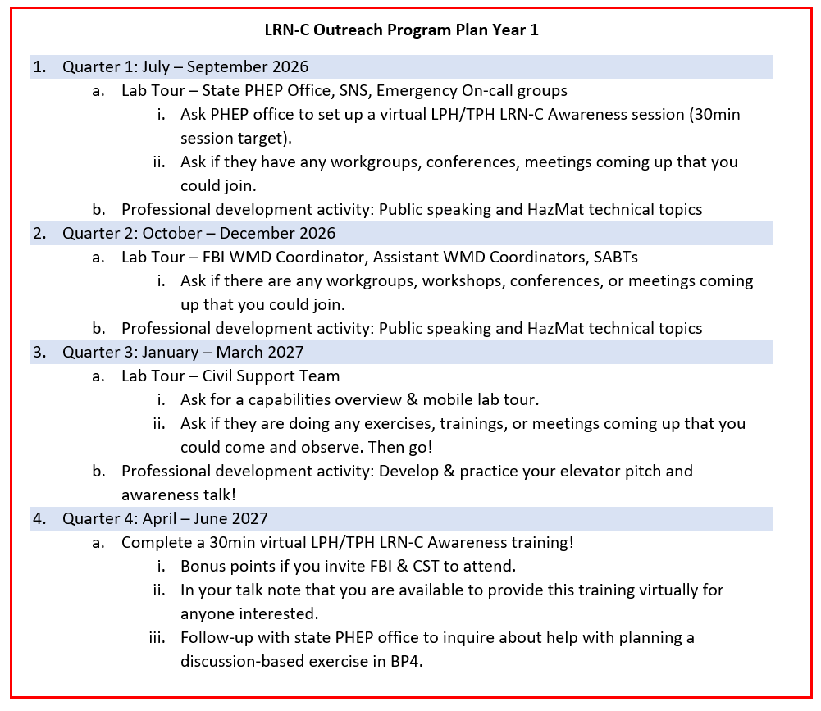
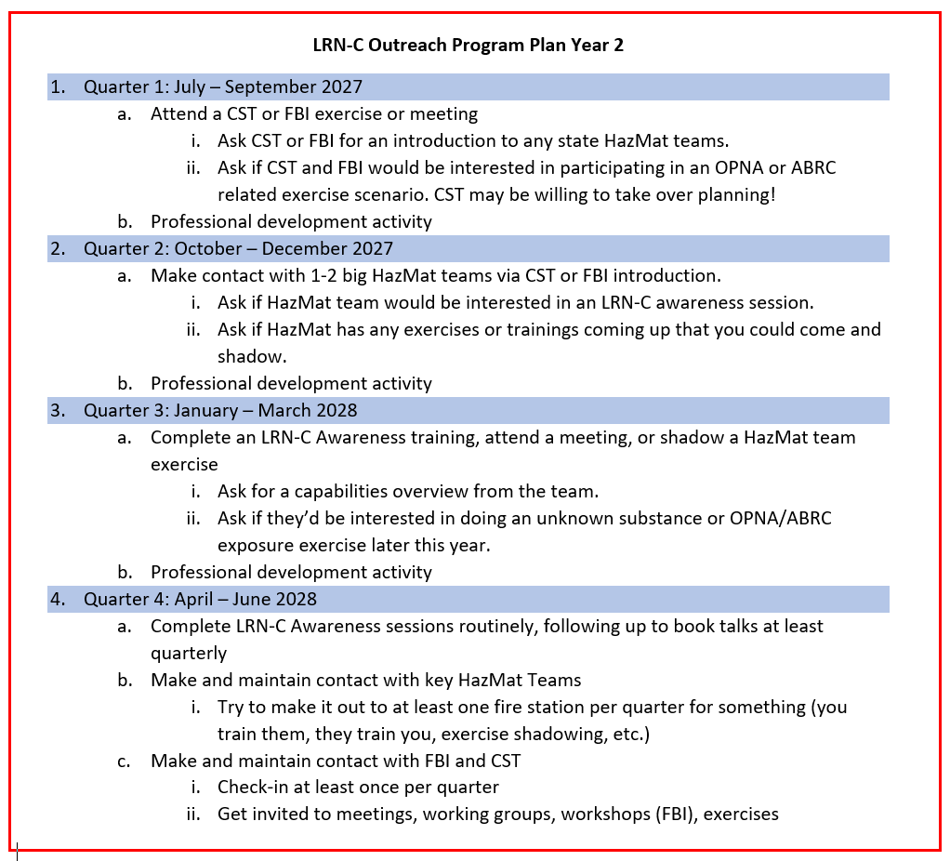
The example outreach plan below illustrates a structured progression from Aware (maturity level 1) to Engaged (maturity level 2) or Integrated-level (maturity level 3) engagement with the identified responder and public safety partners over a two-year period. To progress to Partner (maturity level 4) will likely take time and effort over the course of years and will vary by response partner. Use this example as a reference when developing your own outreach plan:

Year 1 Plan
The plan below has been filled out with the items from the example above; please adjust the objectives, targets and proposed activities as needed to suit your needs:

Quarter 1
- Primary Objective: [Establish initial public health outreach and awareness]
- Target Outreach Maturity Level: Aware (1) → Engaged (2)
- Activities:
☐ [Host laboratory tour for State PHEP, SNS and emergency response groups]
☐ [Coordinate virtual LRN-C Awareness session for LPH and TPH partners]
☐ [Identify and attend relevant meetings, conferences or workgroups]
☐ [Complete professional development in public speaking and HazMat topics]

Quarter 2
- Primary Objective: [Establish relationship with FBI WMD program]
- Target Outreach Maturity Level: Aware (1) → Engaged (2)
- Activities:
☐ [Host laboratory tour for FBI WMD Coordinator, Assistant Coordinators and SABTs]
☐ [Identify opportunities to attend FBI meetings, exercises or workshops]
☐ [Continue outreach presentation skill development]

Quarter 3
- Primary Objective: [Engage Civil Support Team and improve operational understanding]
- Target Outreach Maturity Level: Engaged (2) → Integrated (3)
- Activities:
☐ [Visit Civil Support Team and complete capabilities overview and mobile lab tour]
☐ [Attend or observe CST exercises, meetings or training]
☐ [Develop and practice elevator pitch and outreach awareness presentation]
☐ [Complete follow-up contacts and begin building routine check-ins with target partners]

Quarter 4
- Primary Objective: [Deliver first LRN-C outreach training and begin integration]
- Target Outreach Maturity Level: Engaged (2) → Integrated (3)
- Activities:
☐ [Deliver virtual LRN-C Awareness training session]
☐ [Invite FBI and CST partners to attend]
☐ [Follow up with PHEP office to support future exercise planning]

Year 2 Plan

Quarter 5
- Primary Objective: [Integrate laboratory into responder operational environment for target partners]
- Target Outreach Maturity Level: Engaged (2) → Integrated (3)
- Activities:
☐ [Attend CST or FBI exercise or planning meeting]
☐ [Request introduction to state HazMat teams from CST or FBI]
☐ [Explore participation in OPNA or ABRC exercise planning with CST or HazMat]

Quarter 6
- Primary Objective: [Establish relationships with HazMat teams]
- Target Outreach Maturity Level: Engaged (2) → Integrated (3)
- Activities:
☐ [Make contact with 1–2 HazMat teams]
☐ [Deliver LRN-C Awareness session to HazMat team(s)]
☐ [Attend HazMat meetings, exercises, or training]

Quarter 7
- Primary Objective: [Strengthen HazMat engagement and exercise integration]
- Target Outreach Maturity Level: Engaged (2) → Integrated (3)
- Activities:
☐ [Deliver outreach training or attend HazMat meeting]
☐ [Complete HazMat capabilities overview]
☐ [Explore participation in unknown substance or OPNA/ABRC exercises]

Quarter 8
- Primary Objective: [Establish sustained outreach and partnership relationships]
- Target Outreach Maturity Level: Integrated (3) → Partner (4)
- Activities:
☐ [Deliver routine LRN-C Awareness sessions (target quarterly)]
☐ [Maintain engagement with HazMat teams through visits, exercises or meetings]
☐ [Maintain quarterly contact with FBI and CST]
☐ [Participate in planning meetings, working groups and exercises]

Expected Outcomes by End of Year 2
☐ [Established relationships with key partners (PHEP, FBI, CST, HazMat teams)]
☐ [Routine delivery of LRN-C Awareness training]
☐ [Participation in responder exercises and planning activities]
☐ [Integration of laboratory into responder preparedness and response ecosystem]
☐ [Progression toward Partnership-level outreach maturity]

Appendix: Tables

Table 1. LRN-C Action Options for Stakeholder Engagement and Program Effectiveness
Use this table as a guide to form targeted ideas for LRN-C outreach and partnership building. Note the maturity level impact as a guide point. Frequency will evolve over time. Maturity level may reset due to external factors like response stakeholder turnover that requires a reboot of your outreach program with that stakeholder (e.g., HazMat team member turnover and leadership changes are common). A reset is a great opportunity to revise your LRN-C Outreach program with a particular stakeholder. The recommended frequency is just that—a recommendation; you do what works best for your state and your individual availability as an outreach coordinator.
Outreach Action | Target Partners | Maturity Level Impact | Recommended Frequency | Expected Outcome | Program Effectiveness Impact
Attend HazMat or responder conferences | Fire HazMat  Emergency Management  Law Enforcement | Aware (1) → Engaged (2) | 1–2 times per year | Increased awareness of lab capability and initial introductions | Expands stakeholder visibility
Deliver outreach presentations at responder meetings | Fire HazMat  EMS  Law Enforcement  Emergency Management | Engaged (2) | 2–4 times per year | Responders understand lab role and capability | Builds direct relationships
Host laboratory tours for responder agencies | Fire HazMat (local to your lab)  CST  Emergency Management  Law Enforcement  Public Health | Engaged (2) → Integrated (3) | 1–3 times per year | Improves responder understanding and trust | Strengthens operational relationships
Participate in multi-agency response exercises | Fire HazMat  CST  Emergency Management  Law Enforcement  Public Health | Integrated (3) | 1–2 times per year | Integrates lab into operational response planning | Enhances response readiness
Attend regional emergency planning meetings | Emergency Management  Public Health  Law Enforcement | Engaged (2) → Integrated (3) | Quarterly | Builds ongoing coordination and communication | Improves planning integration
Provide technical consultation on response scenarios | HazMat teams  Emergency Management  Public Health | Integrated (3) → Partner (4) | As opportunities arise | Establishes lab as trusted subject matter expert | Strengthens trust and reliance
Provide responder-focused training sessions | HazMat teams  Fire Departments  CST | Engaged (2) → Integrated (3) | 1–4 times per year | Builds operational awareness of lab support | Improves responder capability integration
Develop outreach contact network database | All partners | Engaged (2) → Integrated (3) | Maintain continuously | Improves communication and coordination | Institutionalizes outreach program
Schedule recurring outreach meetings with key partners | HazMat team leaders  Emergency Management  Public Health | Integrated (3) | Quarterly or semiannual | Sustains relationships and coordination | Strengthens partnership development
Participate in responder conferences as a speaker | HazMat teams  Fire  Emergency Management | Engaged (2) → Integrated (3) | 1–2 times per year | Demonstrates expertise and builds credibility | Enhances program visibility and trust
Participate in incident after-action reviews | HazMat teams  Emergency Management  Public Health | Integrated (3) → Partner (4) | As incidents occur | Improves operational integration and learning | Builds operational credibility
Serve on response planning committees or advisory groups | Emergency Management  Public Safety Leadership  Public Health | Integrated (3) → Partner (4) | Ongoing | Integrates lab into planning and decision-making | Establishes strategic partnership
Provide outreach materials and technical guidance documents | All responder partners | Aware (1) → Engaged (2) | Update annually | Improves understanding of lab services | Supports outreach consistency
Conduct joint training or co-developed outreach programs | HazMat teams  CST  Emergency Management | Integrated (3) → Partner (4) | 1–2 times per year | Establishes shared ownership and trust | Creates sustainable engagement
Provide direct support or consultation during incidents | HazMat teams  Emergency Management | Partner (4) | As needed | Demonstrates operational reliability | Establishes full partnership maturity

Table 2. LRN-C Outreach Barrier Mitigation Reference
Use this table as a guide to form targeted ideas for outreach and partnership building. Frequency will evolve over time. Barriers are not finite and may evolve due to external factors like response stakeholder turnover that requires a reboot of your outreach program with that stakeholder (i.e. HazMat team member turnover and leadership changes are common). Previously non-existent barriers may become an issue and vice versa as outreach programs are dynamic just as our relationships with our response partners are dynamic.
Barrier | Root Cause | Mitigation Strategy | Specific Actions | Expected Outcome
Responders unaware of laboratory capabilities | Lack of outreach or visibility | Increase awareness through direct outreach | Present at HazMat meetings  Attend conferences  Distribute capability summaries | Responders understand lab role and services
Limited relationships with responder agencies | Lack of direct interaction | Build relationships through regular engagement | Attend responder meetings, introduce yourself  Schedule outreach meetings | Improved familiarity and trust
Lack of responder trust in laboratory support | No established operational interaction | Build credibility through participation and support | Participate in exercises  Provide consultation  Attend training events | Increased confidence in laboratory capability
Laboratory not included in exercises or planning | Responders do not consider lab part of response system | Integrate lab into preparedness activities | Request inclusion in exercises  Attend planning meetings  Volunteer participation | Lab integrated into operational planning
Outreach not prioritized internally | Competing laboratory responsibilities | Formalize outreach as program responsibility | Develop outreach calendar  Assign outreach roles  Document outreach activities | Consistent and structured outreach program
Limited time or staffing for outreach | Resource constraints | Focus on high-impact outreach activities | Prioritize conferences, exercises, and key stakeholder meetings | Efficient outreach with maximum impact
Difficulty identifying key partners | Lack of stakeholder mapping | Develop stakeholder engagement plan | Identify HazMat teams, CST, emergency management, law enforcement partners | Comprehensive outreach coverage
Poor communication between lab and responders | No established communication channels | Establish communication pathways | Exchange contact information  Establish points of contact | Improved coordination and responsiveness
Responders unsure when to involve the laboratory | Lack of operational understanding | Provide responder-focused education | Deliver presentations explaining when and how lab supports response | Increased appropriate lab utilization
Outreach efforts inconsistent or unstructured | No formal outreach plan | Develop structured outreach program | Use outreach calendar  Track activities  Set outreach goals | Sustained and measurable outreach progress
Lack of leadership support for outreach | Leadership unaware of outreach importance | Communicate outreach value and impact | Share outreach results  Demonstrate mission impact | Increased organizational support
Limited funding for outreach activities | Budget constraints | Leverage existing opportunities | Attend existing conferences  Integrate outreach into existing meetings | Outreach conducted efficiently
Difficulty engaging responder leadership | Limited access to decision-makers | Engage through professional channels | Attend leadership meetings  Use conference networking opportunities | Improved access and engagement
Outreach not leading to operational integration | Outreach focused only on awareness | Progress outreach toward integration activities | Participate in exercises  Provide consultation  Engage in planning | Stronger operational integration
Partners do not follow up after outreach | Lack of sustained engagement | Maintain ongoing communication | Follow up after meetings  Provide additional resources  Maintain contact | Sustained relationships

Table 3. LRN-C Options to Support and Develop Instructor Confidence
Use this table as a guide to form ideas for how to develop instructor confidence and ability. You have your own voice, your own style. You are welcome in the response community in your state as the representative for your state’s LRN-C program. Give yourself the space to grow and accomplish your outreach objectives. It is ok to fail. We are scientists after all. Science is the art of failure. Change the variables until you achieve the desired results.
Improvement Area | Specific Action | How to Implement | Confidence Benefit | Expected Outcome
Presentation Practice | Practice delivering presentations regularly | Rehearse alone, with colleagues or in small internal groups | Builds familiarity and reduces anxiety | Increased comfort with presentation delivery
Content Mastery | Strengthen understanding of laboratory capabilities and responder relevance | Review lab capabilities, prepare responder-focused explanations, anticipate questions | Improves ability to explain concepts clearly | Greater confidence answering questions
Start with Small Audiences | Present to small or familiar groups first | Present internally or to small responder groups before large conferences | Reduces pressure while building experience | Gradual confidence progression
Observe Experienced Instructors | Watch experienced outreach instructors present | Observe presentations at conferences, note effective techniques | Provides examples of effective delivery | Improved delivery style and engagement techniques
Use Structured Presentation Templates | Follow a consistent presentation structure | Use outreach presentation template and outline | Reduces uncertainty about what to say | More organized and confident delivery
Improve Operational Understanding | Learn responder roles, structure and environment | Attend responder meetings, exercises or training | Increases ability to connect with audience | Improved credibility and confidence
Explain Technical Concepts Simply | Translate laboratory concepts into operational terms | Practice explaining lab capability in responder-relevant language | Improves clarity and effectiveness | Greater audience understanding and instructor confidence
Participate in Exercises | Engage with responders during exercises | Attend and support HazMat or emergency response exercises | Improves familiarity with responder operations | Increased comfort interacting with responders
Prepare for Questions | Develop responses to common responder questions | Create a list of frequently asked questions and answers | Reduces uncertainty during Q&A | Greater confidence during interaction
Receive Feedback | Ask for feedback after presentations | Request feedback from peers, mentors, or responders | Identifies strengths and improvement areas | Continuous improvement in instructor effectiveness
Repeat Presentations | Deliver the same presentation multiple times | Present at multiple meetings, conferences or agencies | Builds experience and familiarity | Increased delivery fluency and confidence
Develop Outreach Relationships | Build relationships with responder partners | Engage regularly with responder agencies outside of presentations | Improves comfort interacting with audience | Stronger trust and instructor confidence
Improve Slide Design | Simplify and improve presentation visuals | Use clear visuals, minimal text and operational examples | Reduces reliance on reading slides | Improved delivery confidence and effectiveness
Mentorship | Work with experienced outreach instructors | Co-present or shadow experienced instructors | Provides guidance and support | Accelerated instructor development
Focus on Operational Relevance | Emphasize how lab supports responder mission | Connect lab capabilities to responder safety and decisions | Improves audience engagement | Increased confidence and credibility

Table 4. LRN-C Common Challenges for Outreach Coordinators
Use this table as a guide to identify instructor challenge areas that can be addressed through professional development.
Category | Challenge
Communication | Translating technical laboratory concepts into operationally relevant language
Communication | Avoiding excessive technical jargon
Communication | Explaining laboratory capabilities clearly and simply
Audience Understanding | Understanding responder roles, priorities, and operational environment
Audience Understanding | Connecting laboratory support to responder decision-making
Confidence | Lack of experience presenting to responder audiences
Confidence | Nervousness or anxiety when presenting
Confidence | Lack of confidence answering responder questions
Delivery Skills | Over-reliance on reading slides
Delivery Skills | Maintaining smooth and confident delivery
Audience Engagement | Keeping responder audiences engaged
Audience Engagement | Encouraging participation and discussion
Audience Engagement | Adjusting delivery based on audience engagement
Content Development | Knowing the appropriate level of technical detail
Content Development | Developing responder-focused presentation content
Content Development | Structuring presentations effectively
Operational Credibility | Establishing credibility with responder audiences
Operational Credibility | Demonstrating operational relevance of laboratory support
Operational Credibility | Understanding responder systems and workflows
Interaction and Questions | Answering unexpected or difficult questions
Interaction and Questions | Managing challenging or skeptical audience members
Interaction and Questions | Maintaining presentation flow during questions
Relationship Development | Limited existing relationships with responder agencies
Relationship Development | Limited opportunities to engage responder audiences
Relationship Development | Maintaining ongoing stakeholder engagement
Program Structure | Lack of structured outreach planning
Program Structure | Limited time available for outreach activities
Program Structure | Balancing outreach responsibilities with laboratory duties

Table 5. LRN-C Strategies to Improve Public Speaking
Use this table as a guide to help improve public speaking ability. It takes time and experience to get good at this, again, give yourself the space to get where you need to be as an instructor.
Strategy Area | Specific Strategy | How to Implement | Benefit
Practice and Repetition | Practice presentations regularly | Rehearse out loud, record yourself, present to colleagues | Builds confidence and improves delivery fluency
Audience Understanding | Learn responder roles and priorities | Attend exercises, meetings and training events | Improves operational relevance and credibility
Simplify Technical Content | Translate technical concepts into plain language | Use simple explanations, avoid jargon use analogies | Improves audience understanding and engagement
Presentation Structure | Use a clear and consistent presentation framework | Organize presentation into opening, key points and closing | Improves clarity and reduces delivery uncertainty
Audience Engagement | Interact with audience during presentations | Ask questions, encourage discussion, maintain eye contact | Increases engagement and instructor confidence
Observe Experienced Instructors | Learn from experienced presenters | Attend presentations and observe delivery techniques | Improves delivery techniques and instructional effectiveness
Slide Design | Improve visual presentation quality | Use minimal text, clear visuals, and structured slides | Improves clarity and reduces reliance on slides
Question Preparation | Prepare for common audience questions | Identify likely questions and develop responses in advance | Improves confidence during interaction and Q&A
Operational Familiarity | Participate in responder activities | Attend exercises, meetings, and field training opportunities | Improves credibility and operational understanding
Feedback and Improvement | Seek feedback after presentations | Ask peers and responders for input and suggestions | Supports continuous improvement
Elevator Pitch Development | Develop and practice a concise outreach message | Prepare and rehearse a 30–60 second introduction | Improves confidence and communication effectiveness
Regular Presentation Experience | Present consistently over time | Deliver outreach presentations regularly | Builds long-term confidence and instructor effectiveness

Table 6. LRN-C Body Language Strategies
Use this table as a guide to help improve public speaking ability. The general rule to follow is if firefighters are sleeping in your class, they are providing feedback that this is not effective engagement. They are a highly expressive group with body language during outreach. Learn to read the room. Try different instruction delivery strategies and watch how they respond and engage with your outreach content. Note, if they were on duty last night and had runs all night long it is highly likely they will tell you—in this instance, sleepers are ok.
Body Language Strategy | What to Do | Why It Matters | Avoid
Confident Posture | Stand upright with relaxed shoulders and balanced stance | Signals confidence and credibility | Slouching, leaning excessively, looking down
Eye Contact | Make intentional eye contact across the audience | Builds trust and engagement | Looking only at slides, notes or one person
Purposeful Hand Gestures | Use natural gestures to emphasize key points | Improves clarity and reinforces message | Hands in pockets, crossed arms, fidgeting
Face the Audience | Keep body oriented toward the audience | Maintains connection and engagement | Turning back to audience or reading slides
Purposeful Movement | Move intentionally and pause for emphasis | Maintains attention and reinforces key points | Pacing, rocking, or standing rigidly
Facial Expressions | Use natural expressions that match your message | Reinforces meaning and improves engagement | Blank expression or appearing disengaged
Strategic Pauses | Pause briefly after important points | Emphasizes key information and builds confidence | Filling silence with “um,” “uh” or filler words
Open Body Language | Maintain open stance with visible hands | Signals approachability and confidence | Crossing arms, hiding hands, closed posture
Minimize Nervous Habits | Maintain steady and controlled movements | Improves credibility and professionalism | Fidgeting, touching face, repetitive movements
Reinforce Key Points Physically | Step forward or gesture during important messages | Helps emphasize importance and improve retention | Remaining static or disconnected from message

