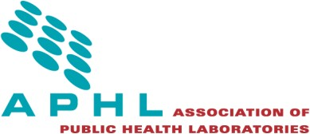
14th National Conference on Laboratory Aspects of Tuberculosis
June 3-4, 2024
Atlanta, GA

Request for Session Proposals
Session proposals are being accepted for the 14th National Conference for Laboratory Aspects of Tuberculosis.

Submitters are encouraged to focus on new knowledge, problems and solutions, and data. Topics of high interest include (but are not limited to):
- Evaluation or comparison of new methods, approaches, algorithms, etc. to improve laboratory efficiency for diagnosis or surveillance
- Biosafety considerations
- Quality assurance
- Continuity of Operations Planning (particularly as it relates to supply chain disruptions)
- Jurisdictional Partnerships (regional networks, laboratory-program, working with the TB Centers of Excellence, private-public laboratory partnerships)
- Successful education/outreach
- Workforce Development/Retention

More details about the submission process are available in the Call for Abstracts document. Proposals should be submitted to infectious.diseases@aphl.org. Submissions are due October 21, 2024.
About the National Conference on Laboratory Aspects of Tuberculosis
The conference consists of 6-8 plenary sessions, including a keynote address, case studies, roundtables, survivor stories, posters and exhibits. Tentatively there will be 5-6 open plenary session slots and 1 open roundtable slot.

Individuals from public health laboratories, governmental laboratories and industry partners who wish to discuss issues relevant to laboratory, programmatic, and clinical aspects of TB testing typically attend.

Plenary session proposals should be targeted to the majority of participants and include diverse perspectives where applicable. Roundtable Proposals should be guided discussions on specific topics. Minimal AV will be supplied (flipcharts, printouts and microphones).
- Plenary sessions are 60 to 90 minutes
- Sessions generally have a moderator and 2-3 speakers
- Panel discussions or other interactive/informational sessions addressing a specific issue or topic may be appropriate
- We strongly encourage sessions to include evidence-based science and participant engagement

