Laboratory Risk Assessment Tool (LABRAT) and Section Summary

Overview:
This tool serves two functions: a risk assessment guide for new or changing processes and the documentation of a job hazard analysis and safety program support needs for each section. Each section must maintain a current Laboratory Risk Assessment Tool (LABRAT) and Sectional Summary.

New or Changing Processes:
Prior to acquiring materials, ordering equipment, or beginning work with a new or changing process (new method, equipment, chemical, sample type, renovation, etc.), supervisors must complete parts 1 and 2 of this document and submit to the Safety Office for review. The Safety Office will then work with the section supervisor to complete the remaining steps and to update the section’s active LABRAT and Section Summary. If underlined items are identified in Part 1, consultation with the safety office is required prior to the acquisition of materials, equipment, or the start of work with the new or changing process.

Instructions:
Part 1: Identify the Hazards
- Review all protocols, Safety Data Sheets (SDSs), package inserts, user manuals, and available information on the new agent, chemical, or process.
- Consider the full process; from the time samples are transported to the building through the time that samples leave the building.
- Use sections 1 and 2 of the LABRAT to assist with the identification of hazards and safety support needs.
- Record identified hazards in sections 1 and 2 of the LABRAT. Provide additional information on the hazard in the space provided (as needed). As an example, a specific chemical could be listed if an underlined hazard class is identified.
Special Situations
- For high risk or newly emerging diseases, a formal agent risk assessment must be included (Attachment 2). This summary will document the rational for the selection of a biosafety level.

Part 2: Evaluate Risk and Prioritize
- Break down all work processes into major tasks; from the time samples are transported to the building through the time that samples leave the building. List these tasks in the first column of section three.
- For each task, brainstorm “What If” scenarios to identify the possible hazards. List these in the appropriate row of the second column in section three.
- For each hazard, use tables A and B below to select values for the likelihood and consequence of the listed hazard occurring.
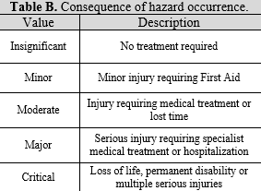
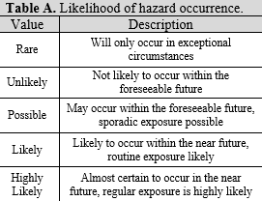
- Use the risk rating matrix, in table C below, to fill in the appropriate initial risk rating for each hazard on the third column of section 3. Evaluate this rating as though no mitigation strategies are in place.
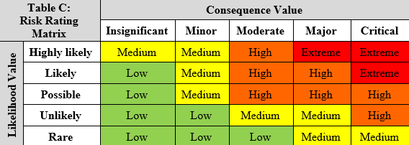
Part 3. Determine Risk Control Strategies
- Select mitigation strategies based on national best practices for safety and the Hierarchy of Controls (Table D). Remember, control strategies near the top of the chart are more effective than those near the bottom and should be considered first where reasonable.
- Record selected mitigation strategies in the fourth column of section 3 of the LABRAT.

Special Situations
- For sections with complicated processes or newly emerging diseases, separate risk assessments (Attachment 3) with summary information recorded in section 3 may be preferred to better separate complex processes.
- For high risk chemicals (those with specific OSHA regulations or listed in subpart Z, NFPA ratings of 4, or with low Permissible Exposure Limits (PEL), specific rows identifying and addressing those chemicals must be included in section 3.

Table D. Hierarchy of Controls
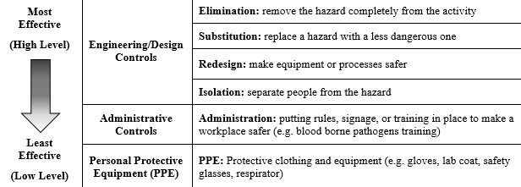
- Determine residual risk ratings for each task using Tables A-C. During this evaluation, consider likelihood and consequence of a hazard after all listed mitigations strategies are in place. Record the residual risk rating in column five in section five of the LABRAT.

- Use Table E to evaluate the residual risk level of each tasks. All reasonable efforts must be made to reduce the risk as much as possible.
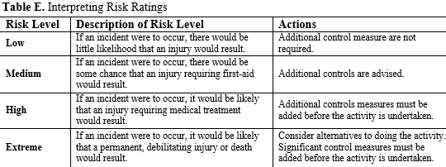

Part 4. Evaluate Safety Support Programs
- Use sections 4-7 of the LABRAT to summarize and consider personal protective equipment, safety equipment, occupational health, environmental monitoring, and training related needs for the section.
- Update and attach a copy of the current chemical inventory. In addition to summarizing the chemical inventory, highlighted neat chemicals on this list must be managed as RCRA, TSCA, or FIFRA hazardous wastes.
- Use section 8 of the LABRAT to list and define mixed chemical and biological waste streams generated from the processes in the section.
Part 5. Document
- Current and completed LABRAT and Section Summaries must be reviewed and approved by the Section Supervisor, Division Director, and Safety Officer.
- The original signed copy will remain on file in the Safety Office. Copies of the original will also be kept by the section supervisor as a reference document.

Attachment 1: Laboratory Risk Assessment Tool and Section Summary
SECTION: |  | DATE:
PREPARED BY: | TITLE:
Rooms:
Section 1: Hazardous Agents / Chemicals
☐ Compressed gases – Inert ☐ Toxicity (inhale) – OSHA Cat 1 or 2 ☐ Lasers
☐ Compressed gases – Hazardous ☐ Toxicity (dermal) – OSHA Cat 1 or 2 ☐ Magnetic fields
☐ Flammables ☐ Toxicity (oral) – OSHA Cat 1 ☐ Radioactive materials
☐ Oxidizers ☐ Reproductive toxins ☐ UV lamps
☐ Corrosive – OSHA Cat 1 or 2 ☐ Carcinogens / Mutagens ☐ BSL-2 agents
☐ Water reactive ☐ Cryogens ☐ BSL-3 agents
☐ Time Sensitive/Reactive ☐ Substances requiring permits ☐ Biological Toxins
☐ Organic peroxides / Peroxide Former ☐ Mercury containing equipment
☐ Other:

Section 2: Hazardous Processes / Conditions
☐ Gases / Fumes produced ☐ Scaffolding / Lifts / Ladders ☐ Ultra-Centrifugation
☐ Aerosols / Particulates produced ☐ Power tool use ☐ Centrifuge
☐ Splash / Splatter Risk ☐ Heavy Lifting >30lbs ☐ Large Volume Reactions
☐ Unguarded moving equipment/parts ☐ Noise > 80 dBA ☐ Concentration / Culture
☐ Pinch / Crush hazards ☐ Ergonomic Risk ☐ After-hours / Working Alone
☐ Projectiles / fragments ☐ Electrical hazards ☐ Transporting hazmat
☐ Pressurized / vacuum system ☐ Thermal hazards (other than class 6.2)
☐ Processes requiring specialty ☐ Hallway storage ☐ Renovation / Repurpose
first-aid. (HF acid)
☐ Other:

Section 3: Laboratory Risk Assessment Worksheet
Task / Procedure | Potential Hazards | Initial Risk | Control / Mitigation | Remaining Risk

Section 4: Personal Protective Equipment
☐ Close-toed shoes ☐ Steel-toed shoes ☐ Leather/Solid Surface Shoes
☐ Standard Lab Coat ☐ Disposable coats ☐ Disposable apron
☐ Safety Glasses ☐ Safety Goggles ☐ Face Shield
☐ Nitrile/Latex Gloves ☐ Viton/Butyl Gloves ☐ Cut Resistant Gloves
☐ Work Gloves ☐ Cryo Gloves ☐ Respiratory Protection
☐ Other:

Section 5: Safety Equipment
☐ Flammable Storage Cabinet ☐ Eye Wash/Safety Shower ☐ Chemical Spill Kit
☐ Acids Storage Cabinet ☐ Splash Guard ☐ Biological Spill Kit
☐ Bases Storage Cabinet ☐ BSC ☐ Formaldehyde Spill Kit
☐ Nitric Acid Cabinet ☐ Fume Hood ☐ Mercury Spill Kit
☐ Fire Extinguisher ☐ First-aid Kit ☐ Special First-aid (specify)
☐ Machine Guarding ☐ LOTO Devices
☐ Other:

Section 6: Occupational Health / Environmental Monitoring
☐ Respiratory Protection Plan
☐ Vaccinations (specify)
☐ Medical Monitoring (specify):
☐ Environmental Monitoring (specify)
☐ Other:

Section 7: Safety Training Summary
☐ General Safety ☐ Biosafety/BBP ☐ DOT/IATA Shipping
☐ Occupational Health ☐ Chemical Hygiene ☐ Respiratory Protection
☐ Security ☐ Hazard Communication ☐ Field Safety
☐ Emergency Preparedness ☐ Compressed Gas Safety ☐ LOTO
☐ First-Aid/CPR/AED ☐ Cryogenic Safety ☐ HAZWOPER
☐ Defensive Driving ☐ BSC / Fume Hood Use ☐ Chemical Waste Management
☐ Other:

Section 8: Waste Streams

Process | Waste Name | Waste Description | Waste Stream (NFPA codes H-F-R) | Section Notes

Notes:

Section Supervisor Date

Division Director Date

Safety Officer Date
Attachment 2: Biological Agent Hazard Assessment
- List the organism of concern.
- List organisms with the same differential diagnosis in the same sample type as the one being tested.
- Indicate the biosafety level (BSL) from BMBL for questions 1 and 2.
- List organism/agent properties:
- Produce toxins?
- Resistance to therapeutics?
- Genetically modified?
- Indicate agent stability:
- Effective disinfectants?
- Environmental survival?
- List known natural reservoirs
- List infectious dose.
- Describe clinical presentation and severity.
- List the incubation period.
- List mortality rates.
- List natural routes of transmission and potential for laboratory acquired infection.
- List if vaccines or treatments are available.
- List at-risk populations
Summary: (justification for biosafety level placement)
References:

Review and Approval:

Name - Section Supervisor Signature Date

Name - Division Director Signature Date

Name - Safety Officer Signature Date

Attachment 3: Expanded Process Attachment - [List Process Name Here]
Task / Procedure | Potential Hazards | Initial Risk | Control / Mitigation | Remaining Risk

