- Fireflies to Frostbite🥶
- This is a team-based wellness challenge where coworkers collectively log physical activity miles (walking, running, rowing, biking, etc.) to “travel” from Nashville, TN to Dr. Levinson’s hometown in Alaska — over 4,000 miles total! Along the way, the group will reach fun milestones with interesting facts, small prizes, and a finisher medal.

- A shared map will visually track our collective progress.

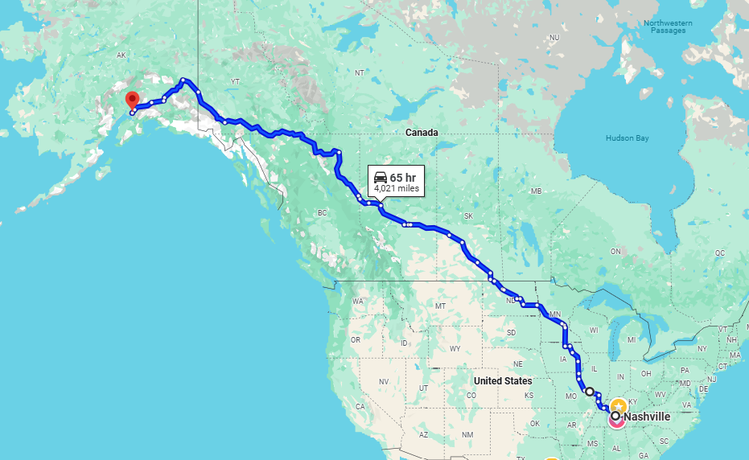

- How it works:
Each week, participants receive a simple online mileage logging form via email. Miles can be logged weekly or as often as preferred. Both team and individual progress are updated weekly through email and on a central bulletin board for motivation and visibility.

