


Delaware Award for Excellence And Commitment in State Service
Nomination Guidelines

The Delaware Award for Excellence and Commitment in State Service (hereafter referred to as the Delaware Award) is presented by the Governor at the annual Statewide Recognition Awards Ceremony held during Public Service Recognition Week.

Purpose
The purpose of the Delaware Award is to recognize the contributions, achievements, dedication, and talents of employees in all levels of Delaware’s state government.

Eligibility
All agencies/departments with approved recognition programs are encouraged to submit nominations for the Delaware Award. Nominees may be an individual or a group of up to five (5) State of Delaware employees. Groups of six or more are not eligible, but are encouraged to apply for the Governor’s Team Excellence Award.

Selection Criteria
Nominees are judged on accomplishments, contributions, and/or performance in state service. This may be a result of a one-time special act, outstanding service or accomplishment, or sustained excellence over a period of time. Sample criteria used by the Selection Committee to review nominations can be found at the end of these guidelines.

Nominators are encouraged to review our Statewide Recognition website for examples of past- recipient contributions that have been recognized in the past.

Selection Committee
The Selection Committee is appointed by the Governor. Members include the President Pro Tempore of the Senate, Speaker of the House, Secretary of Human Resources, and one additional cabinet secretary or agency head, or their designees. In addition, one union official, three state employees (two at or below pay grade 10), and one representative from the private sector are asked to serve. The Selection Committee chooses up to five nominations to submit for the Governor’s approval.

Nominations

Agencies may submit multiple nominations based on the number of full-time equivalent (FTE) positions in their department. To determine the number of nominations submitted by your agency, see the chart to the right.
FTE’s | Nominations
Up to 1,000 | 1
Up to 2,000 | 2
Up to 3,000 | 3
Up to 4,000 | 4
Greater than 4,000 | 5

Agencies typically nominate their department-level Employee of the Year and, if they may make multiple nominations, they typically nominate additional Employees of the Quarter. The agency head or cabinet secretary must endorse all nominees.

Endorsements
Nominations for the Delaware Award must be accompanied by an endorsement from the nominee’s cabinet secretary or agency head. Endorsements may be submitted as PDFs, Word documents, or as an email sent to the agency coordinator, who then attaches it with the submitted nomination.

Nomination Process and Submission Deadline
Nominations should be submitted by agency coordinators with endorsements from their agency head by January 31, by 11:59 p.m. via email to Statewide_Training@delaware.gov with the subject heading Delaware Award for Excellence.

For Further Information or Questions Contact:
Department of Human Resources/Training and HR Solutions, Tel: 302-739-1990 or visit our website at DHR - Statewide Recognition Program (delaware.gov)

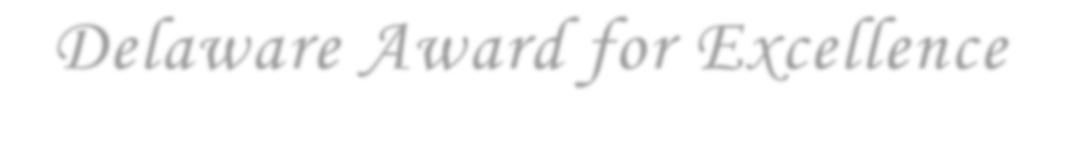
Delaware Award for Excellence
And Commitment in State Service
Criteria for Consideration

The Selection Committee considers the criteria below when reviewing nominations:
- Were the nominees’ efforts part of their regular job duties, or was this a special project (not normally part of their job, but assigned to them or something they volunteered for)?
- Did their efforts have an impact on an entire agency, other agencies, statewide or beyond?
- Are they in a lower pay grade and doing what seems to be above and beyond expectations?

Note:
State employees who demonstrated the use of continuous improvement methodologies and disciplined project management to deliver innovative, impactful, sustainable, and highly efficient business processes and services may be nominated for the GEAR P3 Trailblazer Award.

Teams above five should submit a nomination for the Governor’s Team Excellence Award.

Nominees whose actions were heroic are recommended for the Delaware Award for Heroism, a non- competitive award.

