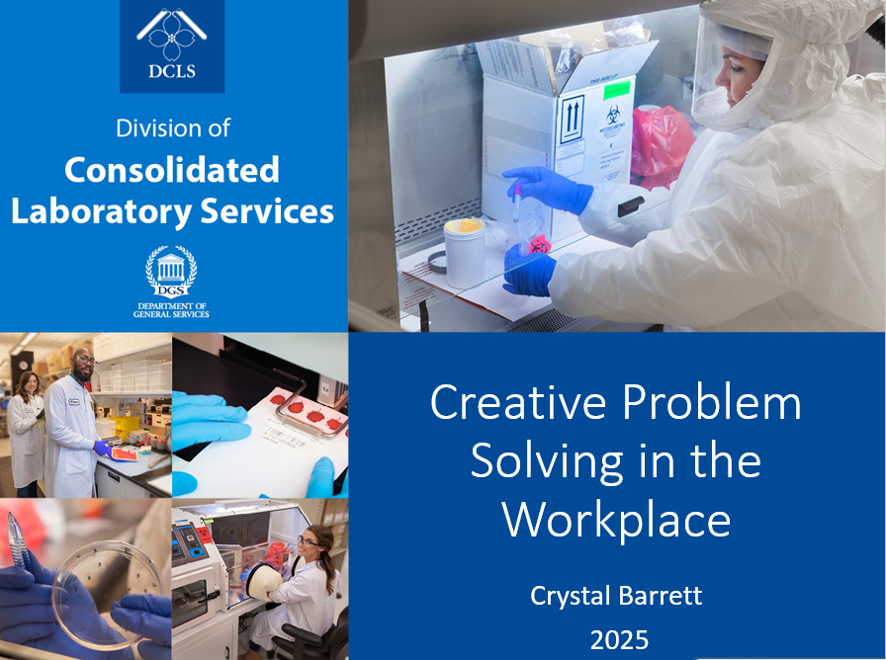

Hand-Outs

WORKSHEET A1. ABBREVIATED CREATIVE PROBLEM-SOLVING WORKSHOP: PARTICIPANT WORKSHEET

Creative Problem Solving Workshop: Participant Worksheet
Name:___________________________________ Date:______________
Workshop Overview:
This worksheet will guide you through the process of creative problem solving, helping you unlock innovative solutions to complex challenges. You will use various techniques to explore, analyze, and solve problems with your fellow participants.

Part 1: Defining the Problem

Part 2: Generating Ideas

Part 3: Evaluating and Selecting Ideas

Part 4: Refining and Testing Solutions
- Develop Your Chosen Idea:
  - What are the steps required to implement your chosen solution? Break it down into action points.

- Possible Obstacles:
  - What challenges might arise when you try to implement this solution? How could you overcome them?

- Test Your Solution:
  - Imagine you’ve successfully implemented your solution. What does success look like? How will you measure if the solution is effective?
Part 5: Reflection
- What Did You Learn About Creative Problem Solving Today?
  - Reflect on how the techniques you used helped you approach the problem in new ways. What surprised you about the process?

- Next Steps:
  - How will you apply creative problem-solving strategies in your daily work or life moving forward?

Exercise: The SCAMPER Technique
Use the SCAMPER method to take a fresh look at your solution. Answer the following questions about your top idea:
- Substitute: Can you replace part of the solution with something else?
- Combine: Can you combine two ideas or solutions?
- Adapt: Can you adapt an idea from another area?
- Modify: Can you change the idea to improve it?
- Put to Another Use: Can the idea be used in a different way?
- Eliminate: What part of the idea can you eliminate to simplify it?
- Reverse: Can you reverse or rearrange the idea to create something new?
Example:
- Substitute: Could we use a free tool instead of paying for a subscription?
- Combine: Could we combine video calls and screen sharing into one app for better ease of use

WORKSHEET A2. COMMON PROBLEMS FOR SMALL TABLE EXERCISE
Here’s a list of common problems or annoying situations that can be solved using creative problem solving. These are everyday issues that often require innovative thinking to improve or resolve:

1. Heavy Traffic on the Way to Work
- Problem: Long commute times and congestion lead to stress, frustration, and wasted time.
- Creative Solutions:

2. Overcrowded Public Transportation
- Problem: Overcrowded trains, buses, or subways during peak hours.
- Creative Solutions:

3. Difficulties in Managing Work-Life Balance
- Problem: Struggling to balance personal and professional commitments, leading to burnout.
- Creative Solutions:

4. Constant Email Overload
- Problem: Too many emails causing distraction, stress, and lack of productivity.
- Creative Solutions:

5. Noise Pollution in Urban Areas
- Problem: Excessive noise from traffic, construction, or neighbors affecting peace and concentration.
- Creative Solutions:

6. Piles of Paperwork and Disorganization
- Problem: Physical paperwork and clutter causing confusion and inefficiency in both home and office environments.
- Creative Solutions:

7. Limited Parking Spaces
- Problem: Struggling to find parking in busy city areas or at crowded events.
- Creative Solutions:

8. Lack of Time for Exercise
- Problem: People struggling to find time to work out regularly due to busy schedules.
- Creative Solutions:

9. Grocery Shopping Takes Too Long
- Problem: Long lines, crowded aisles, and the hassle of grocery shopping.
- Creative Solutions:

10. Poor Sleep Quality
- Problem: Difficulty falling asleep, waking up during the night, or feeling restless.
- Creative Solutions:

WORKSHEET D. SCAMPER METHOD: PARTICIPANT WORKSHEET

Workshop Overview:
This worksheet will guide you through the SCAMPER method, a powerful creative problem-solving tool. SCAMPER stands for Substitute, Combine, Adapt, Modify, Put to Another Use, Eliminate, and Reverse, and it helps you approach problems or ideas from fresh perspectives. You will use this method to innovate and refine your solutions during this workshop.
Part 1: Define Your Idea or Problem
- State the Idea or Problem You’re Working On:
  - What is the concept, product, or issue you want to apply SCAMPER to? Be as specific as possible.
Example:
  - "Our current mobile app lacks user engagement and has a high bounce rate."

- Why is This Idea/Problem Important?
  - Why does this idea or problem matter to you or your team? What impact does it have?

Part 2: Apply the SCAMPER Method
Using the SCAMPER technique, answer the following questions to explore your idea or problem from different angles.
- Substitute:
  - Can you replace part of the current idea, process, or product with something else? Consider materials, people, components, or processes.
Example: "Can we substitute the current onboarding tutorial with a more interactive tutorial?"

- Combine:
  - Can you combine this idea with another idea, product, or concept to create something new? Look for ways to merge strengths from different solutions.
Example: "Could we combine the app’s tutorial with a gamified feature to engage users?"

- Adapt:
  - How can you adapt or adjust the idea to fit a different context or purpose? Consider how similar products, solutions, or industries might solve the problem.
Example: "Could we adapt features from a fitness app to increase user engagement?"

- Modify (or Magnify/Minimize):
  - Can you modify the idea by altering its size, shape, features, or appearance? What can be magnified, and what can be minimized?
Example: "Can we modify the user interface by simplifying it and removing unnecessary elements?"

- Put to Another Use:
  - Can you use the existing idea or product in a different way or in another context? Think about its alternative applications or uses.
Example: "Can we use the tutorial feature as a way to introduce new app features periodically?"

- Eliminate:
  - What elements can you eliminate or remove from the idea, process, or product to simplify it? Are there any unnecessary steps, features, or components?
Example: "Can we eliminate steps in the registration process to reduce user drop-off?"

- Reverse (or Rearrange):
  - Can you reverse, rearrange, or change the order of processes or components? Think about ways to disrupt the current approach by flipping it around.
Example: "Can we reverse the order of the onboarding process by having users complete a quick challenge before showing them the features?"

Part 3: Evaluating Your Ideas
- Which SCAMPER Questions Were Most Useful?
  - Reflect on which SCAMPER steps generated the most creative or practical ideas for your problem. Why do you think they were helpful?

- Which Idea(s) Do You Want to Explore Further?
  - Based on your SCAMPER results, which ideas stand out as the most promising or intriguing? Why?

- Pros and Cons List for the Top Idea(s):
  - Take your top idea and evaluate it by making a pros and cons list.
Example:
Idea: "Simplify the user interface and introduce a gamified tutorial."
  - Pros: More user-friendly, higher engagement.
  - Cons: Time-consuming redesign, may require new resources.
Idea: ___________________________________________
  - Pros: _____________________________________________
  - Cons: _____________________________________________

Part 4: Refining the Idea
- How Can You Test This Idea?
  - What steps would you take to test the new concept or solution in a real-world scenario? How can you validate it before full implementation?

- What Are Potential Obstacles?
  - What challenges could arise when you try to implement this solution? How could you work around them?

Part 5: Reflection and Next Steps
- What Did You Learn From Using SCAMPER?
  - Reflect on how using the SCAMPER method helped you think about the problem or idea in a new way. What surprised you most about the process?

- How Will You Apply SCAMPER in the Future?
  - Think about other projects or problems you might apply SCAMPER to in the future. How can you incorporate this tool into your regular creative problem-solving process?

Thank You!
Thank you for participating in the SCAMPER Method Workshop! We hope you found the exercise useful in generating fresh ideas and solutions. Keep experimenting with SCAMPER, and continue to innovate in your daily work and life!

WORKSHEET E1. PIPELINE ACTIVITY

To Complete this Task:
- Start a timer for the allotted number of minutes
- Review the objectives and safety protocols
- Select a project manager
- Review your ideas and plan how to proceed
- Execute your plan
- Stop wherever you are at the end of the allotted time
- GROUP DEBRIEF with facilitator
RESOURCES
- Allotted number of minutes total time to read the project, plan, and complete the challenge
- Each team has 6 pieces of pipe and one marble
- Each team has one project manager, a time-keeper, and several team members
OBJECTIVE:
The rare RVA Riverhawk has extremely fragile eggs (marble) that must be relocated due to a large construction project happening in their habitat on the James River.
Your team of scientists have created a special set of tools (pipe) that can safely transport the fragile eggs, as long as the safety protocols are followed.
Your objective is for the team to transport your egg from the nest (starting line) along the river pathway (dotted line) to the new habitat (finish line) within the allotted time.
Your efforts will be overseen by a project manager who will observe and note any safety protocol violations.
Safety Protocols (Project Manager ensures compliance):
- All team members must start behind the starting line
- The pipes may never touch each other
- The eggs must never touch any part of the participant
- Once in a pipe, the egg can never stop or move backwards
- Participants with the egg in their pipe cannot move around the room
- The egg must follow the trail
- No additional props, tools or resources may be used
- If any protocol is broken the participant with the egg in their pipe must go back to the starting line

