APHL Annual Conference 2025
One Health Pre-Conference Workshop
May 5, 2025, 8:00 am – 11:00 am Oregon Convention Center
________________________________________________________________________
Implementing One Health Partnerships and Strategies from Within Your Laboratory: Lessons from Rabies and Highly Pathogenic Avian Influenza (HPAI)
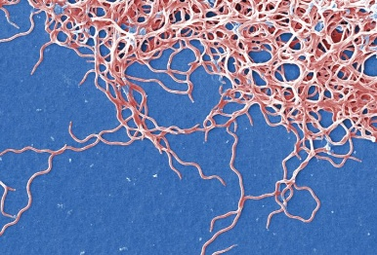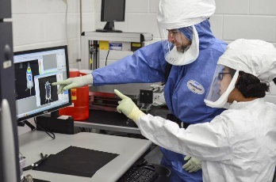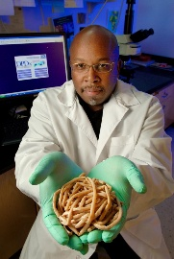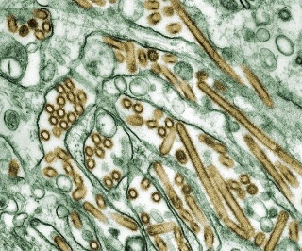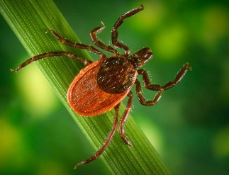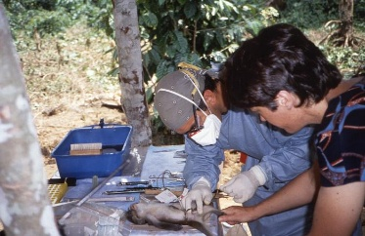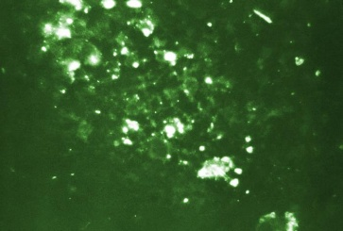

Participant Guide

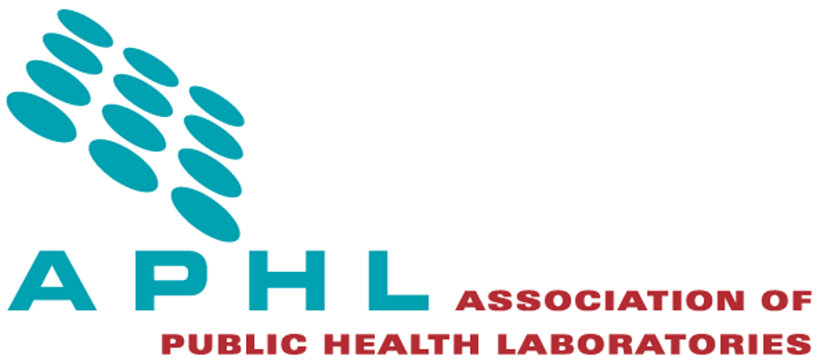

Contents
Welcome 2
Agenda 3
Workshop Outline and General Information 4
Introduction to One Health 6
Rabies Example 8
EXERCISE: Identifying Your One Health Partners 9
One Health Tools, Resources and HPAI Response 13
Commercial Veterinary Diagnostic Laboratory Perspectives on Building One Health Collaborations 15
EXERCISE: Strengthen One Health Connections 16
One Health Fellowship Experience 19
Summary 19
Next Steps and Acknowledgements 20
One Health Resources & References 21

Welcome
- Welcome all participants!
- Please sign the attendance sheet.
- Review housekeeping and any ‘in-case of emergency’ instructions needed.
- Group introductions with workshop team and all participants.

Agenda

Time | Agenda Item and Objective | Discussion Leader
8:00 am | APHL Welcome  Objectives:  - Articulate the One Health concept and its importance in laboratory investigations of zoonotic diseases  - Identify actionable strategies to implement a One Health approach and awareness for their laboratory  - Develop interagency communication plans and collaborations with a One Health perspective | APHL staff  Julie Breher
8:10 am | Introductions and Ice Breaker:  “Who are your One Health partners?” | Moderator: Jeremy Corrigan and Participants
8:25 am | One Health as a collaborative, multisectoral, and transdisciplinary approach, with Rabies as an example | Julie Breher
8:40 am | Exercise: Mapping your steps to bringing One Health partners to the table for HPAI | Moderators: Sarah Wright and Jeremy Corrigan and Participants
8:55 am | Report out: What challenges have been uncovered through this exercise? | Moderators: Sarah Wright and Jeremy Corrigan and Participants
9:05 am | One Health tools and resources, and how they were used in the HPAI response – Raw milk risk assessment example | Ryan Scholz
9:30 am | Break
9:45 am | Commercial Veterinary Diagnostic Laboratory Perspectives on building One Health collaborations | Christian Leutenegger
10:10 am | Exercise: Working together to strengthen One Health connections | Moderators: Alyssa Dickey and Rob Nickla and Participants
10:35 am | Teaching One Health to new scientists: Fellowship experience with HPAI in mammals in Montana | Enrico Di Castro Young
10:50 am | Final thoughts on the exercises, summary strategies and opportunities created today | Moderator: Shari Shea and Participants
10:55 am | Next Steps and acknowledgments | Jeremy Corrigan and APHL staff
11:00 am | Adjourn

Workshop Outline and General Information
DESCRIPTION
Participants will experience how effective collaboration between animal health, public health and environmental sectors strengthens outbreak response, surveillance and disease prevention efforts. Real-world case studies, like rabies and HPAI, will be used to demonstrate best practices for investigating zoonotic diseases, emphasizing the critical role of laboratories in timely detection, reporting and coordination. Participants will be able to describe essential concepts related to One Health and will be provided with tools and resources for developing their own communication and interagency collaboration plans and strategies for enhancing their own laboratories, efforts toward integrating a One Health perspective. Participants will engage with each other and workshop facilitators throughout the day through interactive problem-solving activities.

OBJECTIVES
At the end of the workshop, the participant will be able to:
- Articulate the One Health concept and its importance in laboratory investigations of zoonotic diseases like rabies and HPAI
- Identify actionable strategies to implement a One Health program within their laboratory
- Develop interagency communication plans and collaborations with a One Health perspective

AUDIENCE
Open to local, state and federal level participants from all APHL member categories and partners (e.g., health, environmental, veterinary diagnostics, food safety and agricultural institutions).

LEVEL OF INSTRUCTION
INTERMEDIATE: Refresher course; some basic knowledge is required; for the experienced staff technologist with some years of experience.

PRESENTERS AND WORKSHOP TEAM
- Julie Breher, DVM, MPVM, San Diego County Public Health Laboratory (Presenter)
- Jeremy Corrigan, DrPH, HCLD/TS(ABB), Director, San Diego County Public Health Laboratory (Moderator)
- Enrico Di Castro Young, BS, APHL-CDC Public Health Laboratory Infectious Disease Fellow, Montana Veterinary Diagnostic Laboratory (Presenter)
- Alyssa Dickey, PhD, New York State Department of Agriculture (Moderator)
- Christian Leutenegger, DrMedVet, BSc, PhD, FVH, Vice President R&D, Assay Development Antech Diagnostics, Inc. (Presenter)
- Rob Nickla, M(ASCP), QLS, RBP, CBSP(ABSA), Manager APHL Training (Facilitator)
- Ryan Scholz, DVM, MPH, Oregon Department of Agriculture, Animal Health Program (Presenter)
- Shari Shea, MHS, MT(ASCP), Director, APHL Food Safety (Moderator)
- Sarah Wright, MS, Senior Program Manager, APHL Environmental Health (Moderator)

TOPICS AND EXERCISES
- One Health as a collaborative, multisectoral and transdisciplinary approach, with rabies as an example (Dr. Julie Breher)
- EXERCISE: Mapping your steps to bringing One Health partners to the table
- One Health tools and resources for HPAI response (Dr. Ryan Scholz)
- Commercial veterinary diagnostic laboratory perspectives on building One Health collaborations (Dr. Christian Leutenegger)
- EXERCISE: Working together to strengthen One Health connections (Dr. Julie Breher)
- Teaching One Health to new scientists: Fellowship experience with HPAI in mammals in Montana (Enrico Di Castro Young)

CONTINUING EDUCATION CREDIT
The Association of Public Health Laboratories (APHL) is approved as a provider of continuing education programs in the clinical laboratory sciences by the ASCLS P.A.C.E.® Program. P.A.C.E.® is accepted by all licensure states except Florida. This learning activity will provide 3.0 contact hours for the participant who successfully completes this training.

Introduction to One Health
Articulate the One Health concept and its importance in laboratory investigations of zoonotic diseases like rabies and HPAI
- What is One Health?
  - About One Health | One Health | CDC
  - The One Health approach applies to zoonotic diseases as well as many other health threats at the interconnection between people, animals, plants, and the environment.
  - In addition to zoonotic diseases, mention environmental contamination to help broaden the understanding of One Health.
    - Examples: Hazardous waste spills, pollution, algae blooms
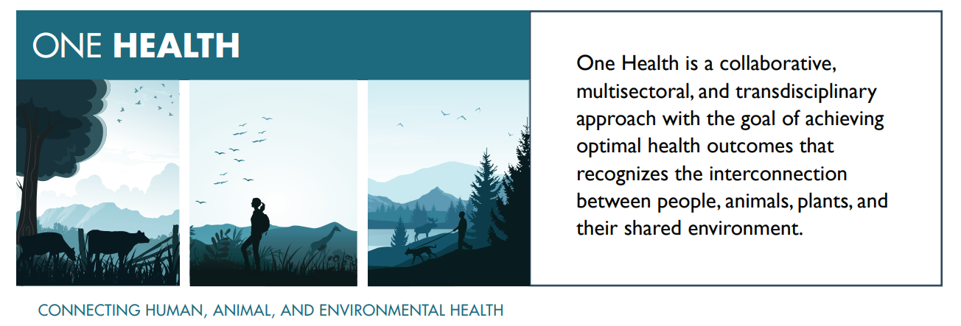
- Why is One Health important to Public Health Laboratories?
  - The One Health approach applies across local, regional, national, and global levels and involves multisectoral coordination and transdisciplinary collaboration of experts across human, animal, plant, environment, and other relevant sectors.
- One Health core concepts and overall mission:
  - Apply the One Health approach to protect people, animals, and the environment in the United States from zoonotic diseases and, advance public health preparedness to optimize health, food safety and security, and sustainability while also promoting biodiversity and conservation outcomes.
  - Implementing the One Health approach to address complex issues is critical to achieving optimal health outcomes, addressing health inequities, and building resilience for all sectors.
  - Many issues can benefit from the One Health approach, including zoonotic diseases (diseases shared between animals and people); emerging and reemerging infectious diseases; antimicrobial resistance; food safety and security; vector-borne diseases; animal health and welfare; responsible wildlife management; threats to our environment and terrestrial and aquatic ecosystems, including invasive species, and loss of biodiversity and habitat; protected areas management and land use changes; and other shared One Health issues.
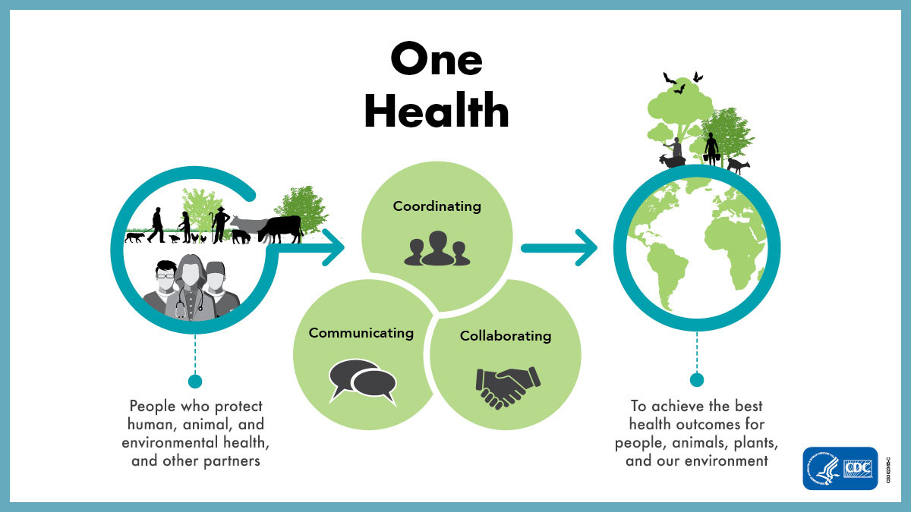
Examples of Zoonotic Diseases & Outbreaks
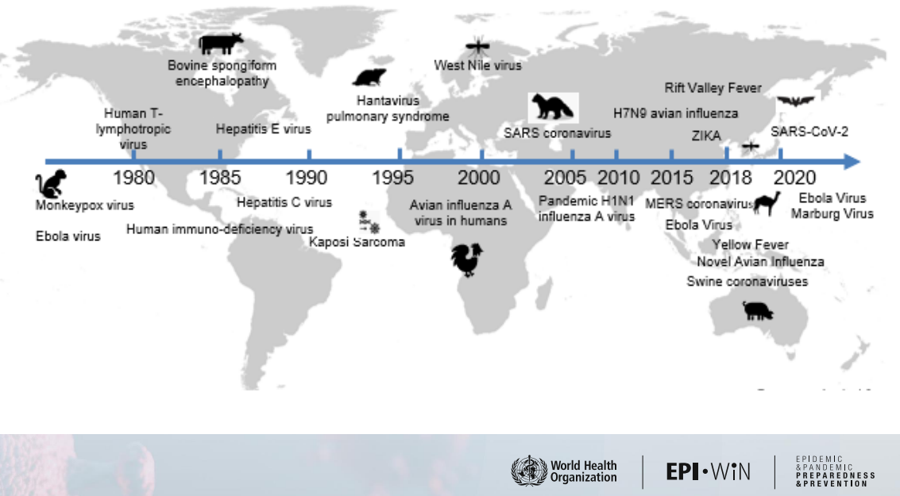
epi_win_digest_4_one-health.pdf

Prioritized Zoonotic Diseases of National Concern in the United States
Identified as part of the 2017 U.S. One Health Zoonotic Disease Prioritization workshop*
1. Zoonotic Influenza
2. Salmonellosis
3. West Nile virus
4. Plague
5. Emerging coronaviruses (SARS, MERS)**
6. Rabies
7. Brucellosis
8. Lyme disease

* For additional context please refer to the full U.S. One Health Zoonotic Disease Prioritization Report
**NOTE: This list was developed in December 2017 prior to the emergence of SARS-CoV-2, the virus that causes COVID-19.

Rabies Example
[PRESENTER Julie Breher] One Health as a collaborative, multisectoral, and transdisciplinary approach, with Rabies as an example.

What were key roles and who were key One Health partners in the rabies examples?

________________________________________________________________________________________________________________________________________________________________________________________________________________________________________________________________________________________________________________________________________________________________________________________________________________________________________________________________________________________________________________________

Additional examples of cross jurisdictional rabies cases:
- Imported Human Rabies --- California, 2008
- Rabies in a Dog Imported from Azerbaijan — Pennsylvania, 2021 | MMWR

EXERCISE: Identifying Your One Health Partners
[MODERATORS Sarah Wright & Jeremy Corrigan] Mapping your steps to bringing One Health partners to the table for Highly pathogenic avian influenza (HPAI).

Identify actionable strategies to implement a One Health program within your laboratory
- How to identify One Health partners.
  - Take into account your ‘starting position’ with One Health experience (i.e., initiating a One Health Program vs. enhancing an existing program).

At each table, participants should be assigned a role to represent in the scenario (e.g., Veterinary, PHL, Epi, Federal partner, etc.) to help with seeing different perspectives and generating more discussion opportunities.
Who are the relevant One Health partners in each scenario?
Scenario 1: There is a large wild duck die off at a pond that lies within 10 miles of a large commercial poultry operation. Testing of several of the ducks revealed positive Flu A test result, indicating HPAI H5N1.
Scenario 2: Several providers in your county are reporting seeing human patients with conjunctivitis and mild ILI (influenza like illness) symptoms in the last 2 weeks. Almost all are testing positive for Flu A. When available, subtyping test results are not detecting H1 or H3.
Scenario 3: The local veterinary medical association in a highly concentrated dairy cattle region calls you to report that several of their member practitioners are reporting seeing increased numbers of cases of severely neurologic cats. Most of the affected cats are dying within 72 hours, some preliminary tests are positive for Influenza A.

Instructions
- Discuss the scenarios at each table.
- Identify who you think your HPAI partners should be.
- Describe how you can approach communication with partners.
- List how you can collaborate with partners.
- Identify any gaps or challenges.

- Who are your relevant One Health partners in the scenarios?
________________________________________________________________________________________________________________________________________________________________________________________________________________________________________________________________________________________________________________________________________________

- Who could or should be a One Health partner if not already mentioned?
________________________________________________________________________________________________________________________________________________________________________________________________________________________________________________________________________________________________________________________________________________

Were all of the following mentioned?
Laboratorians!, Epidemiologists, Health providers (MD, RN, Pharmacist, etc.), Veterinarians (pets, ag, wildlife), Researchers, Academic institutions, Commercial diagnostic labs (both human and animal), Industry research (diagnostics and therapeutics), Federal partners (CDC, USDA, FDA, USGS, OSHA/NIOSH, USFW, etc., State partners (PH, Ag, FW, etc.), Local/regional/tribal (intra & inter), International partners (quadripartite), Environmental Health, Hazmat, APHL!

- Familiarize the roles and responsibilities of all representative One Health partners or sectors.
________________________________________________________________________________________________________________________________________________________________________________________________________________________________________________________________________________________________________________________________________________

- Identify shared objectives and priorities among partners.
  - Is a One Health partnership addressing a specific and identified need?
________________________________________________________________________________________________________________________________________________________________________________________________________________________________________________________________________________________________________________________________________________

Pick some of the following questions to take additional notes as time permits:
- What tools or resources are available to identify One Health partners?
________________________________________________________________________________________________________________________________________________________________________________________________________________________________________________________________________________________________________________________________________________

- How can you initiate or establish contact with One Health partners?
________________________________________________________________________________________________________________________________________________________________________________________________________________________________________________________________________________________________________________________________________________

- How can Public Information Officers (PIOs) play a role?
________________________________________________________________________________________________________________________________________________________________________________________________________________________________________________________________________________________________________________________________________________

- Who are the PHL One Health partners?
________________________________________________________________________________________________________________________________________________________________________________________________________________________________________________________________________________________________________________________________________________

- Who are the One Health partners where you work, if not a PHL?
________________________________________________________________________________________________________________________________________________________________________________________________________________________________________________________________________________________________________________________________________________

- Who are your current response partners that could also be considered One Health partners? (Typical partners ARE the One Health partners!!)
____________________________________________________________________________________________________________________________________________________________________________________________________________________________________________________________
- What is an actionable next step you can take to initiate contact with a new One Health partner?
________________________________________________________________________________________________________________________________________________________________________________________________________________________________________________________________________________________________________________________________________________

- What has led to your state using a One Health approach?
________________________________________________________________________________________________________________________________________________________________________________________________________________________________________________________________________________________________________________________________________________

- If your jurisdiction does use a One Health approach, are there particular disciplines that seem to be more heavily involved/recognized in the process (e.g., environmental vs. animal vs human health aspects).
________________________________________________________________________________________________________________________________________________________________________________________________________________________________________________________________________________________________________________________________________________

Report out / Exercise Summary
- Provide summaries.
- Group discussion of responses.
- What challenges have been uncovered through this exercise?

One Health Tools, Resources and HPAI Response
[PRESENTER Ryan Scholz] Federal One Health tools and resources, and how they were used in the HPAI response

One Health Example Resources and Tools

- Food testing and risk assessments
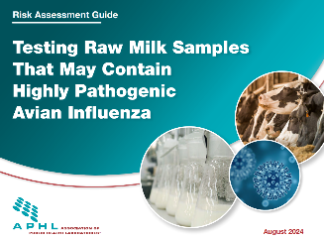
  - How can the APHL resource: ‘Testing Raw Milk Samples That May Contain Highly Pathogenic Avian Influenza’ can be used with essential partners to conduct a thorough risk assessment.
    - Laboratory staff, epidemiologists, sample collection and transport, food testing, etc.
    - APHL Raw Milk Testing Risk Assessment Guidance
  - Regional testing support
    - Bulk milk monitoring from FDA and USDA
  - Example: Cat outbreak
________________________________________________________________________________________________________________________________________________________________________________________________________________________________________________________________________________________________________________________________________________

- 2025-2029 | National ONE HEALTH Framework to Address Zoonotic Diseases and Advance Public Health Preparedness in the United States
  - The first ever National One Health Framework to Address Zoonotic Diseases and Advance Public Health Preparedness in the US includes a common vision, mission, and goals for key federal partners involved in implementing the One Health approach to protect people, animals, and our shared environment from zoonotic diseases and other One Health threats.
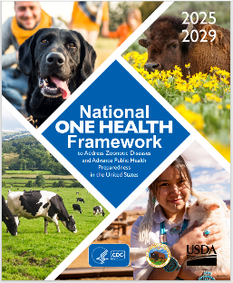

- One Health, Zoonotic Disease Prioritization for Multi-Sectoral Engagement in the United States
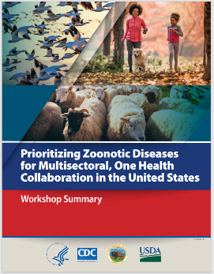
    - CDC, USDA and the US Department of the Interior (DOI) organized a One Health Zoonotic Disease Prioritization workshop to further joint efforts to address zoonotic disease challenges in the US. The workshop was held December 5-7, 2017, at the Department of Health and Human Services (HHS) Office of the Assistant Secretary for Preparedness and Response (ASPR) headquarters in Washington, DC.
    - During the workshop, participants identified a list of zoonotic diseases relevant for the US, defined the criteria for prioritization, and determined questions and weights relevant to each criterion. Participants identified eight zoonotic diseases as priorities using a semi-quantitative selection tool, the One Health Zoonotic Disease Prioritization tool, developed by CDC.

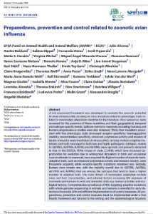
- European Food Safety Authority Publications (EFSA)
    - Preparedness, prevention and control related to zoonotic avian influenza
    - Coordinated One Health investigation and management of outbreaks in humans and animals caused by zoonotic avian influenza viruses

- Minnesota One Health Disease Outbreak Response Tool (OH-SMART)

    - The One Health Systems Mapping and Analysis Resource Toolkit (OH-SMART) is an interactive process that fosters working across organizational and disciplinary lines when preparing or responding to disease outbreaks or addressing other complex One Health challenges.
    - One Health Disease Outbreak Response Tool available from Technology Commercialization
    - One Health Disease Outbreak Response Tool

(Will have a 15 min break here)
____________________________________________________________________________________

Commercial Veterinary Diagnostic Laboratory Perspectives on Building One Health Collaborations
[PRESENTER Christian Leutenegger] Commercial veterinary diagnostic laboratory perspectives on building One Health collaborations

Keys points:
- Relationships that can be formed – partnership intersections
  - Example: Commercial application of affordable testing for veterinary clinicians
- One Health initiative examples: Testing (e.g., zoonotic giardia PCR, hookworm resistance, Echinococcus multilocularis, and HPAI typing) and antimicrobial stewardship
  - Hookworm and the creation of the Rockefeller Sanitary Commission
    - Extending Public Health: The Rockefeller Sanitary Commission and Hookworm in the American South - PMC
    - Public Health: How the Fight Against Hookworm Helped Build a System - REsource
____________________________________________________________________________________________________________________________________________________________________________________________________________________________________________________________________________________________________________________________________________________________________________________________________________________________________________________________________________________________________________________________________________________________________________________________________________

EXERCISE: Strengthen One Health Connections
[MODERATORS Alyssa and Rob] Working together to strengthen One Health connections

Develop interagency communication plans and collaborations with a One Health perspective
- Inviting One Health partners to a discussion for shared objectives and/or priorities.
- How to ‘institutionalize’ these One Health connections.
  - Connect with programs, not just with people.
  - E.g., Formal agreements or contracts
________________________________________________________________________________________________________________________________________________________________________________________________________________________________________________________________________________________________________________________________________________
- Discuss the importance and relevance of contracts, Memorandums of Understanding (MOUs) and Memorandums of Agreement (MOAs) with One Health partners and for helping solidify coordinated plans, such as Emergency Response Plans, Incident Command Systems, Continuity of Operations Plans (COOP), Surge Capacity Plans.
________________________________________________________________________________________________________________________________________________________________________________________________________________________________________________________________________________________________________________________________________________
- Discuss utilizing the APHL L-SIP (Laboratory Systems Improvement Program) to help facilitate One Health partner coordination.
  - Laboratory System Improvement Program
  - QS-2022-LSIP-Toolkit.pdf
  - APHL’s Laboratory System Improvement Program (L-SIP) advances the efficacy of state and local public health laboratory systems through a guided process of performance evaluation, system improvements and periodic evaluation and reassessment. Participating member laboratories receive resources and technical assistance to guide them on their way to system excellence.
  - Connect to your system partners with a Laboratory System Improvement Program (L-SIP) assessment, now available to all state and local public health laboratory systems.
  - Thirty-nine states and seven local municipalities have already completed an L-SIP assessment. Nine states and one local municipality have completed an L-SIP reassessment.
________________________________________________________________________________________________________________________________________________________________________________________________________________________________________________________________________________________________________________________________________________

Additional questions to address as time permits:
- What tools or resources are available to communicate with One Health partners?
________________________________________________________________________________________________________________________________________________________________________________________________________________________________________________________________________________________________________________________________________________
- What tools or resources do you need in your toolbox?
________________________________________________________________________________________________________________________________________________________________________________________________________________________________________________________________________________________________________________________________________________
- Is there a coordinated One Health Response Plan shared among partners?
  - Such as a ‘Feed Response Plan’? Or an MOU/MOA?
________________________________________________________________________________________________________________________________________________________________________________________________________________________________________________________________________________________________________________________________________________
- Can you develop a list of priority zoonotic diseases of greatest concern agreed upon by all represented One Health sectors / partners? Can you identify and rank priorities, then discuss next steps with partners?
________________________________________________________________________________________________________________________________________________________________________________________________________________________________________________________________________________________________________________________________________________

- Do you have insights or specific examples of how using a One Health framework has led to more efficient and effective public health outcomes compared to when One Health was not a well-known concept or not used?
________________________________________________________________________________________________________________________________________________________________________________________________________________________________________________________________________________________________________________________________________________
- What main takeaways would you suggest to environmental/public health laboratories for how they can use One Health to help their jurisdictions to better protect public health?
________________________________________________________________________________________________________________________________________________________________________________________________________________________________________________________________________________________________________________________________________________
- What main takeaways would you suggest to environmental/public health laboratories for how they can use One Health to help their jurisdictions to better protect public health?
________________________________________________________________________________________________________________________________________________________________________________________________________________________________________________________________________________________________________________________________________________
- How do you think your jurisdiction could benefit from any of the examples/strategies discussed today?
________________________________________________________________________________________________________________________________________________________________________________________________________________________________________________________________________________________________________________________________________________
- How can we help the greater APHL community to more effectively use any aspect of One Health to help their jurisdictions better protect public health? What resources can be shared or developed to support this?
________________________________________________________________________________________________________________________________________________________________________________________________________________________________________________________________________________________________________________________________________________

One Health Fellowship Experience
[PRESENTER Enrico Di Castro Young] Teaching One Health to new scientists: Fellowship experience with HPAI in mammals in Montana

Keys points:
- Fellowship experience in a Veterinary Diagnostic Laboratory and what interactions and relationships exist with the State Public Health Laboratory
- Fellowship project overview and fellowship experience
  - HPAI PCR for domestic pet development and assay implementation
  - Testing for other pathogens
- One Health perspective, from a Fellow’s point of view
____________________________________________________________________________________________________________________________________________________________________________________________________________________________________________________________________________________________________________________________________________________________________________________________________________________________________

Summary
[MODERATORS Jeremy & Shari] Final thoughts on the exercises, summary strategies and opportunities created today

Keys points to address:
- Review the workshop objectives.
- Review resources and tools discussed.
- List summaries of exercise findings.
- Public Health vs. One Health
  - “Humans” tend to be the primary focus of public health, whereas a One Health perspective, as seen in the veterinary community, ALL animals are taken into consideration, including how humans get injected into the mix.
  - Veterinary and agricultural disciplines “live” in the One Health world all the time.
  - Animals in the environment are sentinels for human diseases.
- Reinforce One Health mission and overall objectives.
  - CDC works closely with the US Department of Agriculture (USDA), the Department of the Interior (DOI), and many other federal agencies to exchange information and coordinate One Health activities across the United States government.
  - Implementing the One Health approach means involving all relevant sectors concerning human, animal, plant, and environmental health to address health concerns in a more collaborative, effective, efficient, and sustainable manner than each sector approaching these issues alone.

Next Steps and Acknowledgements
[MODERATORS Shari & Jeremy]
- Call to action: How to use the information, tools and other resources from this workshop to enhance One Health programs.
- Available workshop materials to adapt for PHL use.
- Adjourn and thank you!

One Health Resources & References
Key Partners and Partnerships

- Academic Institutions
- APHIS (Animal and Plant Health Inspection Services)
- APHL (Association of Public Health Laboratories)
- AMA (American Medical Association)
- APHA (American Pharmacists Association)
- ARS (Agricultural Research Service)
- ASPR (Administration for Strategic Preparedness and Response)
- AVMA (American Veterinary Medical Association)
- CDC (Centers for Disease Control and Prevention)
- Commercial Diagnostic Laboratories (animal and human)
- DHS (U.S. Department of Homeland Security)
- DOC (Department of Commerce)
- DOD (U.S. Department of Defense)
- DOE (U.S. Department of Energy)
- DOI (U.S. Department of the Interior)
- DOS (U.S. Department of State)
- EPA (Environmental Protection Agency)
- Epidemiology
- FDA (Food and Drug Administration)
- FEMA (Federal Emergency Management Agency)
- FS (Forest Service)
- FSIS (Food Safety and Inspection Service)
- FWS (U.S. Fish and Wildlife Service)
- Hazmat
- Health Providers (MD, RN, Clinician, Pharmacist, etc.)
- HRP&O (Health Readiness Policy and Oversight)
- IA (Indian Affairs)
- Industry Research (diagnostics and therapeutics)
- NIH (National Institutes of Health)
- NIFA (National Institute of Food and Agriculture)
- NIOSH (National Institute for Occupational Safety and Health)
- NPS (National Park Service)
- NOAA (National Oceanic and Atmospheric Administration)
- OASD[HA] (Office of the Assistant Secretary of Defense for Health Affairs)
- OES/ECW (Bureau of Oceans and International, Environmental and Scientific Affairs, Office of Conservation and Water)
- OGA (Office of Global Affairs)
- OHS (Office of Health Security)
- OSHA (Occupational Safety and Health Administration)
- Other Laboratorians!
- Public Health (state and local)
- SC (Office of Science)
- Toxicology
- USBR (Bureau of Reclamation)
- USDA (U.S. Department of Agriculture)
- USGS (U.S. Geological Survey)
- Veterinarians (pets, agriculture, wildlife)

APHL Resources
- Laboratory System Improvement Program
- QS-2022-LSIP-Toolkit.pdf
- L-SIP Fact Sheet
- Milk-HPAI Risk Assessment
National Guidance
- 2025-2029 | National ONE HEALTH Framework to Address Zoonotic Diseases and Advance Public Health Preparedness in the United States
- One Health | One Health | CDC
- One Health Communication Resources | One Health | CDC
- Federal One Health Coordination | One Health | CDC
- One Health, Zoonotic Disease Prioritization for Multi-Sectoral Engagement in the United States
- One Health Zoonotic Disease Prioritization (OHZDP) | One Health | CDC
- Zoonoses & One Health Updates (ZOHU) Call Webinar Series | One Health | CDC
- Preparedness, prevention and control related to zoonotic avian influenza | EFSA
International Guidance
- One Health
- Coordinated One Health investigation and management of outbreaks in humans and animals caused by zoonotic avian influenza viruses | EFSA
- One Health - WOAH - World Organisation for Animal Health
- Preparedness, prevention and control related to zoonotic avian influenza
Workshop References
- AC25_Precon_Flyers_OneHealth.pdf
- https://www.cdc.gov/one-health/media/pdfs/us-ohzdp-report-508.pdf
- A One Health framework for exploring zoonotic interactions demonstrated through a case study | Nature Communications
- A generalizable one health framework for the control of zoonotic diseases | Scientific Reports
- The Importance of the One Health Concept in Combating Zoonoses - PMC
- Extending Public Health: The Rockefeller Sanitary Commission and Hookworm in the American South - PMC
- Public Health: How the Fight Against Hookworm Helped Build a System - REsource
- Imported Human Rabies --- California, 2008
- Rabies in a Dog Imported from Azerbaijan — Pennsylvania, 2021 | MMWR
Exercise & Workshop Guidance
- Homeland Security Exercise and Evaluation Program (HSEEP)
- Guidance & Tools | Health Literacy | CDC
- Integrated Preparedness Planning Workshop Guide [TEMPLATE]
- Conducting Exercises
- Exercise Templates · NETEC Education and Resources · NETEC Resource Library
- Trainer_Observation.docx
- Evaluation1.docx
Image References
- epi_win_digest_4_one-health.pdf
- https://phil.cdc.gov/Details.aspx?pid=13170
- https://phil.cdc.gov/Details.aspx?pid=9813
- https://phil.cdc.gov/Details.aspx?pid=7663
- https://phil.cdc.gov/Details.aspx?pid=12760
- https://phil.cdc.gov/Details.aspx?pid=27717
- https://phil.cdc.gov/Details.aspx?pid=25641
- https://phil.cdc.gov/Details.aspx?pid=22455
- https://phil.cdc.gov/Details.aspx?pid=1841

