Guidance for Swab Collection of

Carbapenem-Resistant Organisms (CRO)
 |  | 
Texas Department of
State Health Services
Revised January 2023
Texas Antimicrobial Resistance Lab Network
Texas Department of State Health Services
[arln inbox address]
[arln webpage address]
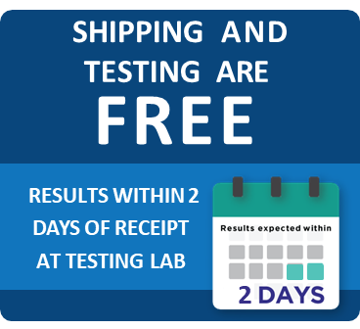  Sections  General Information 1  Screening Patients 2  Obtaining Patient Consent 3  Materials Required 3  Collecting Specimens 4  Labeling, Forms, Storage 5  Packaging Specimens 6  Shipping Specimens 7  Example Script for Consent 8  Acknowledgements 8  Attached Separately:  Patient FAQ  Guidance for Use of ARLN FedEx Account | Purpose  These guidelines will aid healthcare, laboratory, and public health professionals in the collection and shipment of Carbapenem-resistant organisms (CRO). CRO infections are difficult to treat and can spread quickly to other facilities in the region, making them a serious threat to public health.  CRO screening can allow Texans to receive improved targeted treatments and provide Texas healthcare systems valuable data to prevent the spread of CROs across the region.  Colonization Screenings  - Are performed after a confirmed CRO infection or due to suspected local transmission.  - Must be approved by a state or local HAI/AR epidemiologist and approved by the intended testing public health laboratory.  - Contact: [ICAR email address]  - Swabs must be shipped to DSHS within 1 day of collection  - Please attach copies of any prior antibiotic sensitivity testing results with swabs  Cepheid GeneXpert Carba-R Test  The Cepheid GeneXpert Carba-R test is the only FDA-approved commercial test for the molecular detection of carbapenem resistance in human rectal swab specimens and has a rapid turnaround time for results.  Healthcare facilities, laboratories, and epidemiologists can work with the state HAI Coordinator to order screening and associated materials, free of charge.


Guidance for Swab Collection of CROs

Guidance for Swab Collection of CROs

Guidance for Swab Collection of CROs

Guidance for Swab Collection of CROs

Guidance for Swab Collection of CROs

Guidance for Swab Collection of CROs

Guidance for Swab Collection of CROs

Guidance for Swab Collection of CROs
  Contact Screening Rationale  Facility staff should consider screening patients with the following factors that impact the likelihood of acquiring or transmitting CROs.  - Increased Risk Factors for CRO Acquisition and Transmission  - Long length of stay (usually longer than 3 days)  - Presence of wounds  - Intensity of aid required for daily living activities (toileting, bathing, eating, dressing, ambulating)  - Exposure to broad-spectrum antibiotics  - Indwelling medical devices (respirators, gastrostomy tube)  - Bedbound  - Incontinence  - Index Patient Exposure  - Were precautions followed strictly or inconsistently?  - Which patients interacted or shared living spaces with the index patient?  - Sharing similar activities or types of care (e.g., dialysis, wound care, whirlpool, PT/OT equipment) with the index patient.  - Exposure Duration and Ongoing Transmission  - How many days did the index and contact share a ward/unit?  - Should a broader group be screened?  - Confirm transmission is halted with the use of point prevalence surveys and follow-up surveys.  Additional Resources for CRO Contact Screening Guidance:  - The rationale for CDC screening recommendations  - https://www.cdc.gov/hai/pdfs/cre/CRE-guidance-508.pdf (Revised November 2015)  - How to screen appropriately based on risk  - Health-Response-Contain-MDRO-H.pdf (cdc.gov)  (Revised January 2019)  For additional questions, please contact:  - [ICAR email address]  - [MDRO email address] |       State and regional labs work together to:  Detect resistant species & emerging threats  Perform susceptibility testing and track resistance  Coordinate responses to outbreaks

Page 2

Page 2
Guidance for Swab Collection of CROs

Guidance for Swab Collection of CROs

Guidance for Swab Collection of CROs

Guidance for Swab Collection of CROs

Guidance for Swab Collection of CROs

Guidance for Swab Collection of CROs

Guidance for Swab Collection of CROs

Guidance for Swab Collection of CROs
Obtaining Patient Consent  Prior to sample collection, the patient or proxy MUST provide informed consent and understand the collection procedure of a rectal swab.  The patient should be informed about why it is recommended that they be screened and informed about the procedure for collection of a rectal swab. The patient, or their guardian, should have an opportunity to ask questions.  ★ For quick reference, an example script for requesting consent  is on the last page at the back of this packet. An FAQ page has been attached separately for easier photocopying.  Patients should be given a copy of the FAQ and contact information for the state or local health department for any future questions that may arise.  Materials Required  After obtaining patient consent, don proper PPE such as  Since the Insert command embeds a copy, the picture is always visible, but it may greatly increase the size (in bytes) of your newsletter, depending on how large the picture is.  In contrast, Link to File does not increase the size of your newsletter file, and if you make changes to the original picture, they automatically show up in the newsletter. But the picture won’t display if viewed from a computer that can’t link to the original (for instance, if the original picture is stored on another computer on a network).  Insert and Link inserts a copy so that the image is always available, and also automatically updates changes to the original.  You can replace the pictures in this template with your company’s art.  To do so, click where you want to insert the picture. On the Insert menu, point to Picture, and then click From File. Locate the picture you want to insert, and then click it. Next, click the arrow to the right of the Insert button, and then click either Insert to place a copy of the picture into the newsletter, Link to File to display the picture without actually inserting a copy, or Insert and Link.  Since the Insert command embeds a copy, the picture is always visible, but it may greatly increase the size (in bytes) of your newsletter, depending on how large the picture is.  In contrast, Link to File does not increase the size of your newsletter file, and if you make changes to the original picture, they automatically show up in the newsletter. But the picture won’t display if viewed from a computer that can’t link to the original (for instance, if the original picture is stored on another computer on a network).  Insert and Link inserts a copy so that the image is always available, and also automatically updates changes to the original.  You can replace the pictures in this template with your company’s art.  To do so, click where you want to insert the picture. On the Insert menu, point to Picture, and then click From File. Locate the picture you want to insert, and then click it. Next, click the arrow to the right of the Insert button, and then click either Insert to place a copy of the picture into the newsletter, Link to File to display the picture without actually inserting a copy, or Insert and Link.  Since the Insert command embeds a copy, the picture is always visible, but it may greatly increase the size (in bytes) of your newsletter, depending on how large the picture is.  In contrast, Link to File does not increase the size of your newsletter file, and if you make changes to the original picture, they automatically show up in the newsletter. But the picture won’t display if viewed from a computer that can’t link to the original (for instance, if the original picture is stored on another computer on a network).  Insert and Link inserts a copy so that the image is always available, and also automatically updates changes to the original.  You can replace the pictures in this template with your company’s art.  To do so, click where you want to insert the picture. On the Insert menu, point to Picture, and then click From File. Locate the picture you want to insert, and then click it. Next, click the arrow to the right of the Insert button, and then click either Insert to place a copy of the picture into the newsletter, Link to File to display the picture without actually inserting a copy, or Insert and Link.  Since the Insert command embeds a copy, the picture is always visible, but it may greatly increase the size (in bytes) of your newsletter, depending on how large the picture is.  In contrast, Link to File does not increase the size of your newsletter file, and if you make changes to the original picture, they automatically show up in the newsletter. But the picture won’t display if viewed from a computer that can’t link to the original (for instance, if the original picture is stored on another computer on a network).  Insert and Link inserts a copy so that the image is always available, and also automatically updates changes to the original.  You can replace the pictures in this template with your company’s art.  To do so, click where you want to insert the picture. On the Insert menu, point to Picture, and then click From File. Locate the picture you want to insert, and then click it. Next, click the arrow to the right of the Insert button, and then click either Insert to place a copy of the picture into the newsletter, Link to File to display the picture without actually inserting a copy, or Insert and Link.  Since the Insert command embeds a copy, the picture is always visible, but it may greatly increase the size (in bytes) of your newsletter, depending on how large the picture is.  In contrast, Link to File does not increase the size of your newsletter file, and if you make changes to the original picture, they automatically show up in the newsletter. But the picture won’t display if viewed from a computer that can’t link to the original (for instance, if the original picture is stored on another computer on a network).  Insert and Link inserts a copy so that the image is always available, and also automatically updates changes to the original.  You can replace the pictures in this template with your company’s art.  To do so, click where you want to insert the picture. On the Insert menu, point to Picture, and then click From File. Locate the picture you want to insert, and then click it. Next, click the arrow to the right of the Insert button, and then click either Insert to place a copy of the picture into the newsletter, Link to File to display the picture without actually inserting a copy, or Insert and Link.  Since the Insert command embeds a copy, the picture is always visible, but it may greatly increase the size (in bytes) of your newsletter, depending on how large the picture is.  In contrast, Link to File does not increase the size of your newsletter file, and if you make changes to the original picture, they automatically show up in the newsletter. But the picture won’t display if viewed from a computer that can’t link to the original (for instance, if the original picture is stored on another computer on a network).  Insert and Link inserts a copy so that the image is always available, and also automatically updates changes to the original.  You can replace the pictures in this template with your company’s art.  To do so, click where you want to insert the picture. On the Insert menu, point to Picture, and then click From File. Locate the picture you want to insert, and then click it. Next, click the arrow to the right of the Insert button, and then click either Insert to place a copy of the picture into the newsletter, Link to File to display the picture without actually inserting a copy, or Insert and Link.  Since the Insert command embeds a copy, the picture is always visible, but it may greatly increase the size (in bytes) of your newsletter, depending on how large the picture is.  In contrast, Link to File does not increase the size of your newsletter file, and if you make changes to the original picture, they automatically show up in the newsletter. But the picture won’t display if viewed from a computer that can’t link to the original (for instance, if the original picture is stored on another computer on a network).  Insert and Link inserts a copy so that the image is always available, and also automatically updates changes to the original.  You can replace the pictures in this template with your company’s art.  To do so, click where you want to insert the picture. On the Insert menu, point to Picture, and then click From File. Locate the picture you want to insert, and then click it. Next, click the arrow to the right of the Insert button, and then click either Insert to place a copy of the picture into the newsletter, Link to File to display the picture without actually inserting a copy, or Insert and Link.  Since the Insert command embeds a copy, the picture is always visible, but it may greatly increase the size (in bytes) of your newsletter, depending on how large the picture is.  In contrast, Link to File does not increase the size of your newsletter file, and if you make changes to the original picture, they automatically show up in the newsletter. But the picture won’t display if viewed from a computer that can’t link to the original (for instance, if the original picture is stored on another computer on a network).  Insert and Link inserts a copy so that the image is always available, and also automatically updates changes to the original. |   Inform patients of the collection procedure, answer any questions, and provide a copy of FAQs and contact information.    Always practice effective hand hygiene and don proper PPE (gloves, gown, mask) prior to collecting samples.  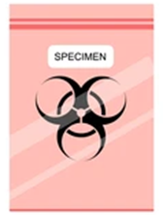  Every specimen should have its own submission form.

Materials Required
- Before beginning, perform hand hygiene and wear appropriate PPE as indicated by the patient’s clinical care team (e.g., gloves, gown, mask).
- Collection Swabs must be made by Copan and compatible with the Cepheid GeneXpert Carba-R testing platform.
  - Cepheid Sterile Transport Dual Swab, catalog # 900-0370

  - Optionally, parafilm may be used to further ensure the swab container is leakproof.
- Correct Patient Specimen Label
- Biohazard Specimen Bag
- Submission Form G-2E
Additional details regarding shipping, labeling, and form guidelines are covered on pages 5-7

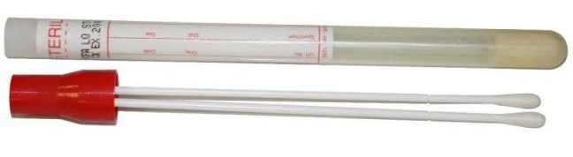
Guidance for Swab Collection of CROs

Guidance for Swab Collection of CROs

Guidance for Swab Collection of CROs

Guidance for Swab Collection of CROs

Guidance for Swab Collection of CROs

Guidance for Swab Collection of CROs

Guidance for Swab Collection of CROs

Guidance for Swab Collection of CROs

Page 3

Page 3

Page 3

Page 3

Page 3

Page 3

Page 3

Page 3

Page 3

Page 3

Page 3

Page 3

Page 3

Page 3

Page 3

Page 3

Page 4

Page 3

Page 3

Page 3

Page 3

Page 3

Page 3

Page 3

Page 3

Page 3

Page 3

Page 3

Page 3

Page 3

Page 3

Page 3
Guidance for Swab Collection of CROs
Guidance for Swab Collection of CROs

Guidance for Swab Collection of CROs

Guidance for Swab Collection of CROs

Guidance for Swab Collection of CROs

Guidance for Swab Collection of CROs

Guidance for Swab Collection of CROs

Guidance for Swab Collection of CROs

Guidance for Swab Collection of CROs
Specimen Collection Procedure  - Open the outer plastic packaging on the end that says, “PEEL HERE” on the end opposite to the cotton tips.  - Carefully remove the tube from the plastic packaging and label the tube (labeling guidelines on next page).  - Pull the dual swab from the plastic packaging, being careful not to touch the cotton tips.  - The dual swab may be moistened with sterile saline or transport medium only  - Do NOT use tap water or lubricating gel  - Insert the swab 1 cm (½ inch) beyond the anal sphincter, or approximately one inch into his or her rectum, gently rotate against the walls of the rectum 3 times (Figure 1) and then remove it.  - Diapered infants: For diapered infants, the cotton swab may be used to swab the stool present in the soiled diaper.  - Patients with an ostomy: Use the cotton applicator to obtain specimen from the stoma site.  - Neutropenic patients: Follow facility guidelines for collection of specimens and follow clinical judgements.  - Confirm the swab has an acceptable amount of matter (Figure 2) and that it is not overloaded (Figure 3) or underloaded.  - Insert dual swab into collection tube and firmly close cap (Figure 4).  - Affix patient label to specimen.  - Optionally, parafilm may be wrapped around each individual tube to further leakproof the container. |  | Figure 1. Proper Swab Depth is 1cm beyond the anal sphincter, or approximately 1 inch  into the patient’s rectum.  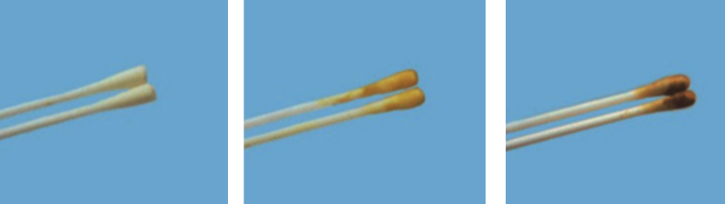  Figure 2. Acceptable Specimens  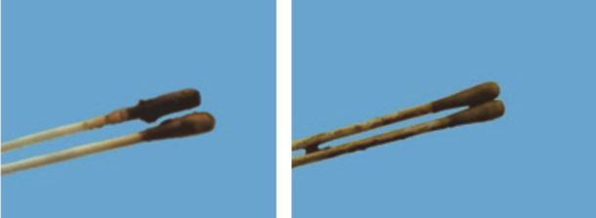  Figure 3. Unacceptable Specimens  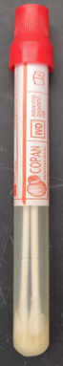  Figure 4. Closed Collection Tube (left)  Closed Collection Tube with Additional Parafilm Leakproofing (right)
Guidance for Swab Collection of CROs  Specimen Labeling & Submission Form  Each specimen must be clearly labeled with:  - A minimum of two unique patient identifiers.  Acceptable identifiers include:  - Full Patient Name  - Date of Birth  - Unique identification number  - Medical Record Number  - Sample ID  - CDC Number  - Medicaid / Medicare Number  - Date of specimen collection  - Site of collection (rectal swab, sputum, etc.)  Printed labels and/or legible handwritten information on the specimen container are both acceptable.  At least two acceptable patient identifiers must be present on the primary specimen receptacle (swab tube) and match the G-2E submission form exactly.  Specimens received with insufficient or mismatched information cannot be tested.  Request G-2E forms from:  Laboratory Reporting Group  Fax: (###) ###-####  [ lab email address]  Storage  Copan Cepheid swabs can be stored and transported at room temperature  (15-28°C).  - Please be sure to ship swabs within 1 day of collection.  - Coordinate timing of colonization swabbing and specimen shipping  with DSHS epidemiologists and the Texas DSHS laboratory’s schedule.  - Testing must be performed within 5 days of collection.  - Dry ice should not be used for shipment.  - Cold packs may be considered if shipping temperatures  are expected to exceed 28°C.  Guidance for Swab Collection of CROs  Page 6  Page 3  Page 3  Page 3  Page 3  Page 3  Page 3  Page 3  Page 3  Page 3  Page 3  Page 3  Page 3  Page 3  Page 3  Page 3  Specimen Packaging  Primary Receptacle  Primary receptacles house the submitted specimen and must be a plastic container.  - Specimens collected with the Cepheid swabs and tube are in an acceptable primary receptacle (Figure 5).  - The screw cap of the swab collection container must be sealed.  - Parafilm can be used to ensure containment of swab (Figure 5).  Secondary Packaging  Secondary receptacles are leak-proof material that seals, cushions, and surrounds the primary receptacle.  - Generally, sealed plastic specimen bags are accepted as a secondary receptacle.  - Multiple collection tubes may be placed in the same bag (Figure 5).  - To minimize cross-contamination, please individually bag each collection tube before combining into one large bag.  - Do not overfill the bag with too many tubes; the bag MUST be sealed completely.  - Absorbent material (e.g. absorbent pads, paper towels, or cotton balls) should be placed in the bag with the tubes in case of leakage.  Secondary Container  - A sealable, Styrofoam cooler that makes up the outermost layer of secondary packaging.  - Copan Cepheid swabs can be transported at room temperature (15-28°C).  - Cold packs may be considered if shipping temperatures are expected to exceed 28°C. Dry ice should not be used.  Sturdy Outer Packaging  - FedEx requires the outer packaging box be made of corrugated cardboard or wood (Figure 6).  - Foam boxes, paper bags, and envelopes are not acceptable as an outer package for FedEx shipping of these specimen types.  - The box should be an appropriate size to encase the bag of swabs; not too big and not too small.  Line list/Manifest of Specimens  - A line list of specimens is required in shipment.  - Must be placed between the secondary container and the outer packaging.  - Each specimen received should have an individual G-2E form with matching identifiers located on the tube (page 5). At least two acceptable patient identifiers must be present on the primary receptacle (swab tube) and match the G-2E submission form exactly.  Guidance for Swab Collection of CROs  Page 7  Page 3  Page 3  Page 3  Page 3  Page 3  Page 3  Page 3  Page 3  Page 3  Page 3  Page 3  Page 3  Page 3  Page 3  Page 3  Shipping and Transport  Guidelines may vary from transporter to transporter; however, guidelines below are catered to FedEx requirements because the Texas DSHS Laboratory and the CDC are using FedEx as the designated transporter for ARLN specimens.  Copan Cepheid swab specimens fall under the International Air Transport Association’s (IATA) “Category B”. The IATA guidelines require three receptacles to package and ship Category B substances that are highlighted in this guideline.  A special permit/certification is not required to ship a Category B substance; however, training is necessary to ensure proper packaging of shipments and to reduce risks of exposure during transportation. Training may be informal, consisting of a documented review of Category B shipping practices.  General Considerations for Shipping  - Please ensure that employees tasked with packing and/or shipping swabs are properly trained.  - Employers/leadership must be responsible for training employees shipping Copan Cepheid swabs.  - Packages containing biohazards should NEVER be dropped off at a FedEx Express® Drop Box.  - Must be labeled with:  - UN 3373 label – with 6-mm-high text stating  “Biological Substance, Category B”  - Swabs should be processed within 48 hours of collection. Therefore, it is imperative that swabs are shipped to the Texas lab within one day of collection. Please keep in mind when shipping prior to weekends or holidays to alter your collection dates accordingly.  Submitter ID Request  - All Submitters MUST Have a Submitter ID Number with DSHS. If you do not already have an account or submitter ID number or you need to update information already on file, please download a Submitter ID Number Request Form and fill it out.  - Complete all applicable fields and email the completed form to labinfo@dshs.texas.gov, or fax it to (512) 776-7533. Once a facility’s information is verified, a submitter ID account is created.  Absorbent materials |  | Page 5  Page 3  Page 3  Page 3  Page 3  Page 3  Page 3  Page 3  Page 3  Page 3  Page 3  Page 3  Page 3  Page 3  Page 3  Page 3    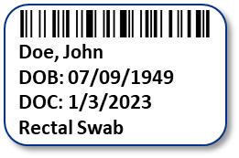  1  2  3  An example specimen labeled correctly with two unique identifiers, collection date, and collection site.  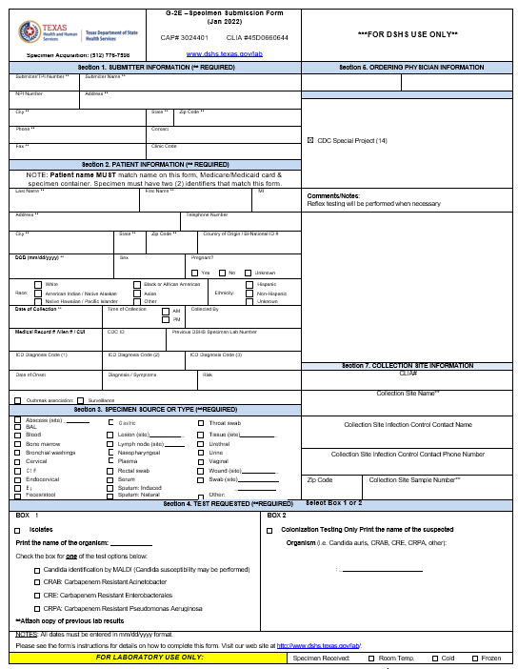  An example G-2E form used for submitting specimens to TX DSHS.    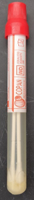  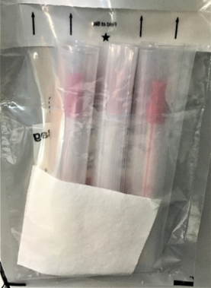  Figure 5. Closed Collection Tube (left).  Closed Collection Tube with Additional Parafilm Leakproofing (middle). Individually bagged collection tubes grouped in one secondary package (right).  Acceptable Sturdy Outer Packaging  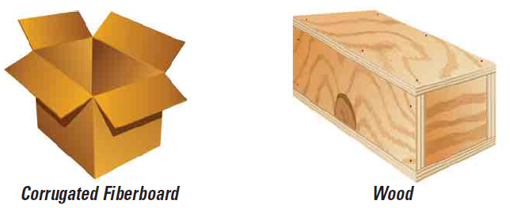  Unacceptable Outer Packaging  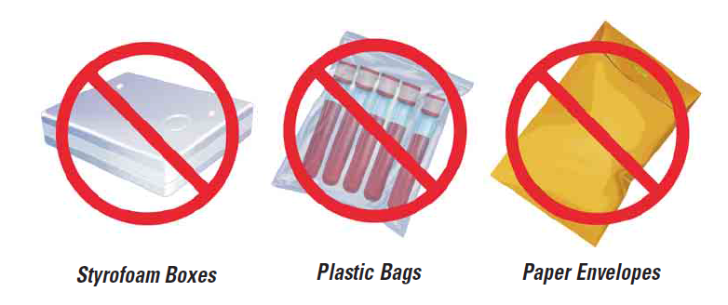  Figure 6. Acceptable vs unaccaptable outer packaging  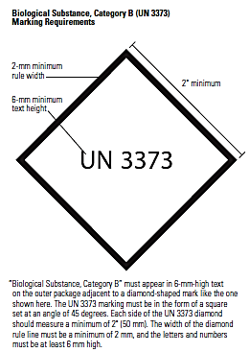  Documentation  Refrigerated or Frozen Cold Packs  Leakproof secondary receptacle  Leakproof primary receptacle  Styrofoam secondary container  Rigid Outer Packaging with Category B UN 3373 Label  Guidance for Swab Collection of CROs  Page 8  Page 3  Page 3  Page 3  Page 3  Page 3  Page 3  Page 3  Page 3  Page 3  Page 3  Page 3  Page 3  Page 3  Page 3  Page 3  Example Script for Requesting Consent to Perform CRO Colonization Swabs  Hi, my name is [insert name] and I work for [insert organization]. I’m here to talk to you about some screening the [insert healthcare facility] is doing to check for a rare germ. Recently, a patient who was cared for at this facility was identified to be carrying a rare germ. The germ is called a carbapenem-resistant organism, or “CRO” for short.  We are screening patients, such as yourself, for this germ because some people can carry this and spread it to others unknowingly.  The chance that you carry this germ is very low. Fortunately, most people who do carry it never get sick from it. However, in order to prevent the spread of CRO, the local health department would like us to screen patients to make sure they don’t have it.  If you agree to be screened, the process is very simple and takes just a few seconds. We would need to swab inside your rectum. To do that, we would gently insert just the tip of a soft swab, which looks like a Q-tip, into your rectum, gently rotate it, and then remove it. The process is not painful, but may be uncomfortable for a few short moments. There shouldn’t be any side effects.  The swab will be sent to a lab to test for the bacteria, which will take a few days. If they find the germ, someone will contact you to discuss what to do next. The results of the test will be kept confidential to the extent allowed by law.  Providing a swab is completely voluntary and you can choose not to be tested.  Do you have any questions? [pause for questions]  Is it OK if we collect the swab?      Texas Antimicrobial Resistance  Lab Network  TexasARLN@dshs.texas.gov  Texas Department of State Health Services  dshs.texas.gov/laboratory-services/programs-laboratories/antibiotic-resistance-lab-network  Acknowledgements:  Images used from the Centers for Disease Control and Prevention, Cepheid, Maryland Public Health Lab, Utah Public Health Lab, & University of New Hampshire  Texas Antimicrobial Resistance Lab Network  [ARLN inbox address]  Texas Department of State Health Services  [ARLN webpage URL]  Patient FAQ –  Sample Collection for Antimicrobial Organisms        Texas Department of  State Health Services  Revised January 2023  Your healthcare facility has identified a person with a type of  bacteria (a kind of germ) that is resistant to important antibiotics  that are used to treat infections. When bacteria are resistant  to an antibiotic, it means that the drug will not work to treat  infections caused by those bacteria.  Why have I been contacted?  - To make sure this type of resistant bacteria does not spread further, the healthcare facility or health department is contacting people who might have had contact with this bacteria. They are requesting that these people get a screening test to make sure they are not also carrying the bacteria.  Why is it important for me to be tested for this bacteria?  - It is important for you to be tested for this germ so that the healthcare facility and health department can prevent it from spreading. Preventing the spread of these bacteria is very important because we do not want these resistant bacteria to spread further.  What happens if these bacteria are found in or on me?  - The results of the test will be kept confidential to the extent allowed by law. The results will be shared with you and your healthcare providers and might be shared with the health department.  - The risk to you from this germ is low. Most people carry these bacteria and never get sick from them. If you receive medical care, your healthcare providers may take extra steps to protect you and make sure they do not spread the bacteria to other patients.  How can I be tested for this germ?  - People carry this kind of germ in their gut or stool, so the best way to test for these bacteria is to swab your rectum. If you agree to be tested, a healthcare provider will gently insert just the tip of a soft swab that looks like a Q-tip into your rectum, gently rotate it, and then remove the swab. The procedure is not painful and there should be no side effects. The swab will be sent to a lab and, within a few days, the lab will report the result to your healthcare provider.    Do I have a choice to be tested?  - Yes, providing a swab is voluntary. You can choose to decline testing. However, if you decline testing and you receive medical care, your healthcare providers might take extra precautions, such as wearing a gown and gloves when caring for you, since they will not know if you have this germ.  I want to be tested, but I am not comfortable having a rectal swab collected. Is there an alternative test?  - At this time, there are no alternative tests approved by the FDA.  If my test is positive, what will I need to do?  - The risk of spreading this germ to your family and friends is very low, but family and visitors should wash their hands well after caring for you or visiting you to decrease their chance of getting the germ. You should also wash your hands frequently, especially after using the bathroom and before eating or preparing food.  - If you receive medical care at a healthcare facility such as a hospital or nursing home, be sure to let your healthcare providers know about the results so that they can take steps to prevent spreading the germ to others.  If my test is positive, will I need treatment?  - If the test is positive, it means you are carrying the germs in your gut. Many people carry these bacteria without feeling sick, and they may even stop carrying these bacteria over time. However, this depends on many factors. You should discuss your results with your healthcare team regarding if treatment is necessary and the next steps to take.  - Your healthcare providers might recommend you get an additional test later to see if the germ is gone. However, a follow-up test will not be recommended for everyone.  Patient FAQ –  AR Sample Collection  Page 2  Page 3  Page 3  Page 3  Page 3  Page 3  Page 3  Page 3  Page 3  Page 3  Page 3  Page 3  Page 3  Page 3  Page 3  Page 3  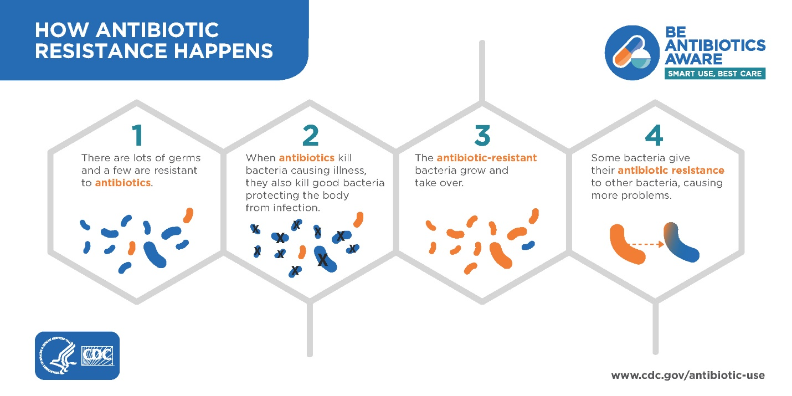

Texas Antimicrobial Resistance Lab Network
[ARLN Email Address]
Texas Department of State Health Services
[ARLN webpage URL]

FedEx Account
- Please contact [ARLN Email Address] for instructions and to gain login access to the FedEx account.
- When you log in to the FedEx site, please follow these steps:
- Verify the address you are shipping from or change it
  - Under "From", click "Edit" and enter your facility information. Check "save new sender in address book" so that you can use the same information in the future

Texas Department of
State Health Services
Revised January 2023

Guidance for Use of the AR Lab Network FedEx Account

- Enter the recipient’s information.
  - Under "To", please select contact name "[NAME]" (Texas DSHS).
  - The Texas DSHS Laboratory address will be populated for you.
    - If it does not, please use:
Texas Department of State Health Services
Laboratory Services Section
[Address Line 1]
[City, State, Zip]
- Enter information under package and shipment details. Priority Overnight is the only available option for AR Lab Network Account.
- Click the Edit link in special services to view and/or choose any special services related to your shipment.
  - Please make sure to double check under "special service". If you are not sending anything on dry ice, please make sure "dry ice" is not checked.

Guidance for ARLN FedEx Account Use

Page 2

Page 3

Page 3

Page 3

Page 3

Page 3

Page 3

Page 3

Page 3

Page 3

Page 3

Page 3

Page 3

Page 3

Page 3

Page 3

- When you’re ready, verify all information was correctly filled out and select “Ship”.
- Print the appropriate shipping label(s) for your shipment.

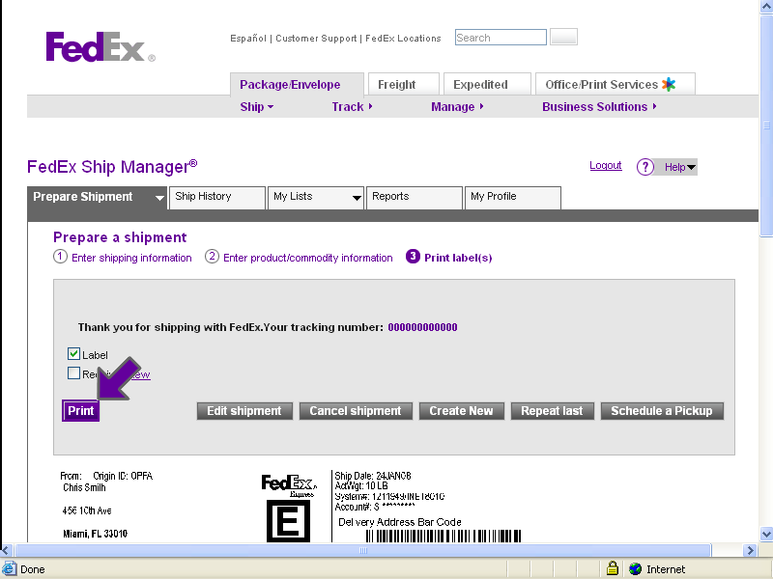

Visit our webpage for updates, forms, and shipping info:
- [URL
  - https://www.dshs.texas.gov/laboratory-services/programs-laboratories/antibiotic-resistance-lab-network/3-shipping-instructions

Guidance for ARLN FedEx Account Use

Page 3

Page 3

Page 3

Page 3

Page 3

Page 3

Page 3

Page 3

Page 3

Page 3

Page 3

Page 3

Page 3

Page 3

Page 3

Page 3

