Human and Animal Food Laboratory Professionals Curriculum Framework
A team of Subject Matter Experts (SMEs) are building a competency-based curriculum framework for human and animal food laboratory professionals. The goal of the framework is a competent laboratory workforce doing comparable work as part of the Integrated Food Safety System.
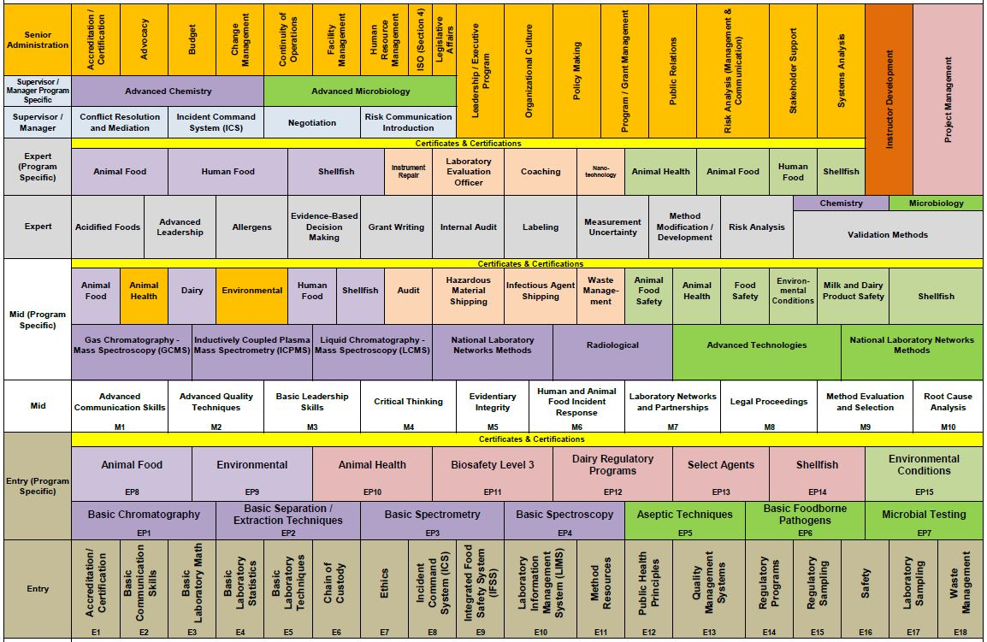
The curriculum framework is a career-spanning, visual schematic of the human and animal food laboratory profession.
The framework spans five professional levels (Entry, Mid, Expert, Supervisor/Manager, and Senior Administration), and depicts the content areas in which laboratory professionals must possess competencies (i.e., knowledge, skills, abilities, behaviors, and attributes) in order to successfully perform their job functions. Content areas are either core (applying to all laboratory professionals) or program-specific (applying to laboratory professionals specializing in either Chemistry, Microbiology, or both).
The curriculum framework is being used for: 1) training development (courses and other learning events), 2) cataloging existing training, and 3) competency assessment.
Framework development workshops are held approximately twice a year at the APHL headquarters in Silver Spring, MD. The SMEs participating in these workshops represent a range of stakeholders including but not limited to APHL, AFDO, AAFCO, FDA, and state laboratories.
The curriculum framework project is supported by the FDA Office of Training Education and Development (OTED).
With support from OTED, a similar framework for human and animal food regulators is under development. More than twenty online courses are now available free of charge to regulators, with many more courses currently under development.

